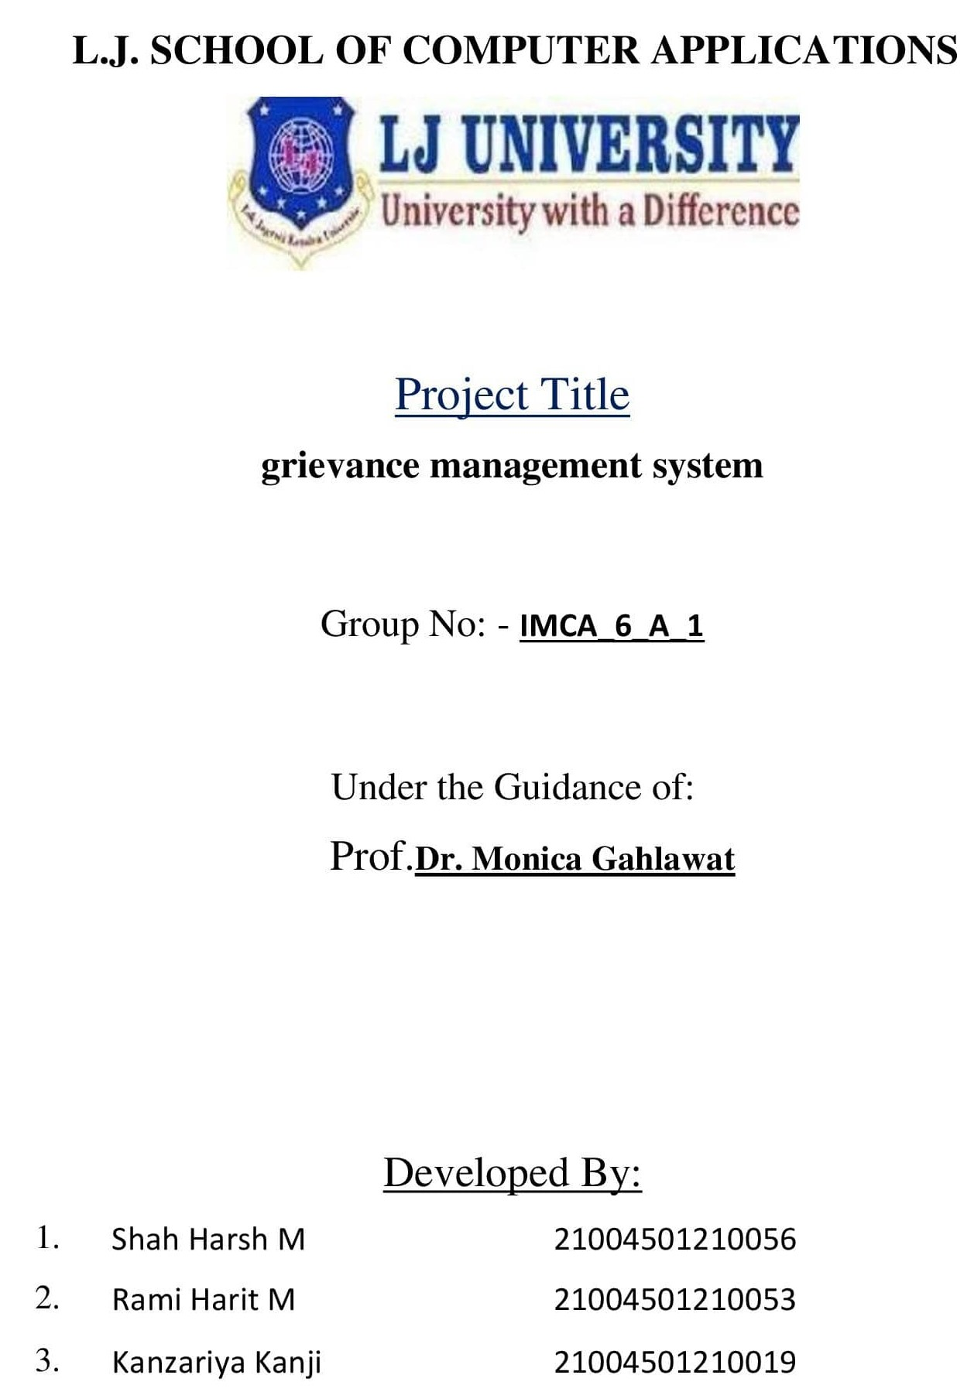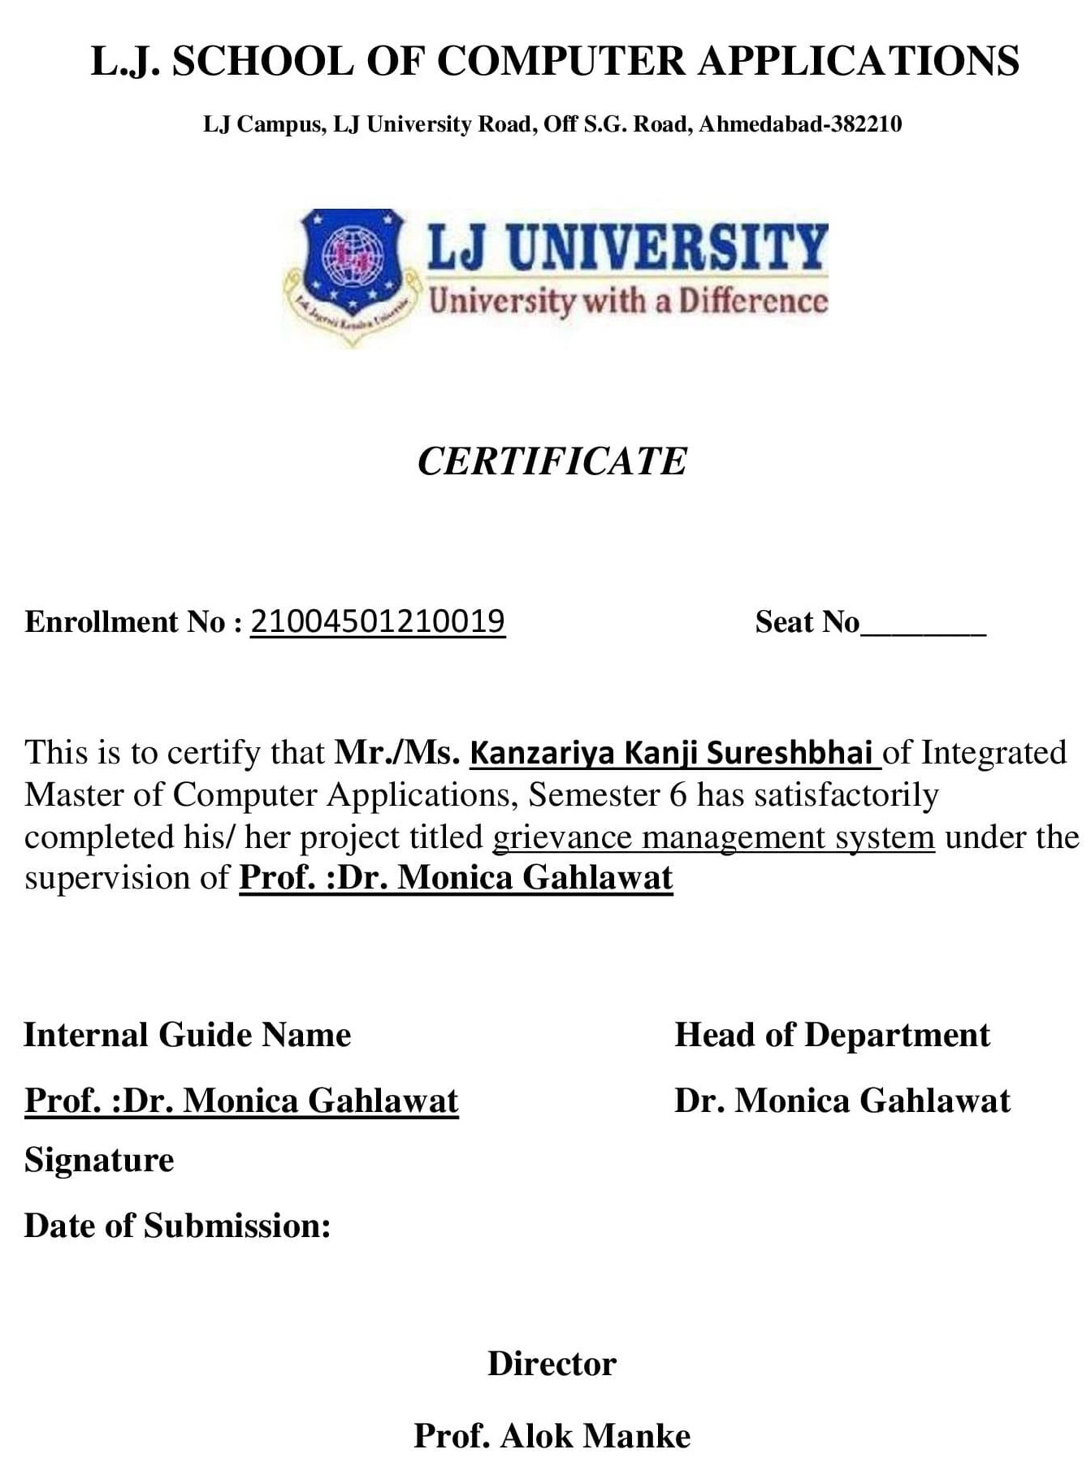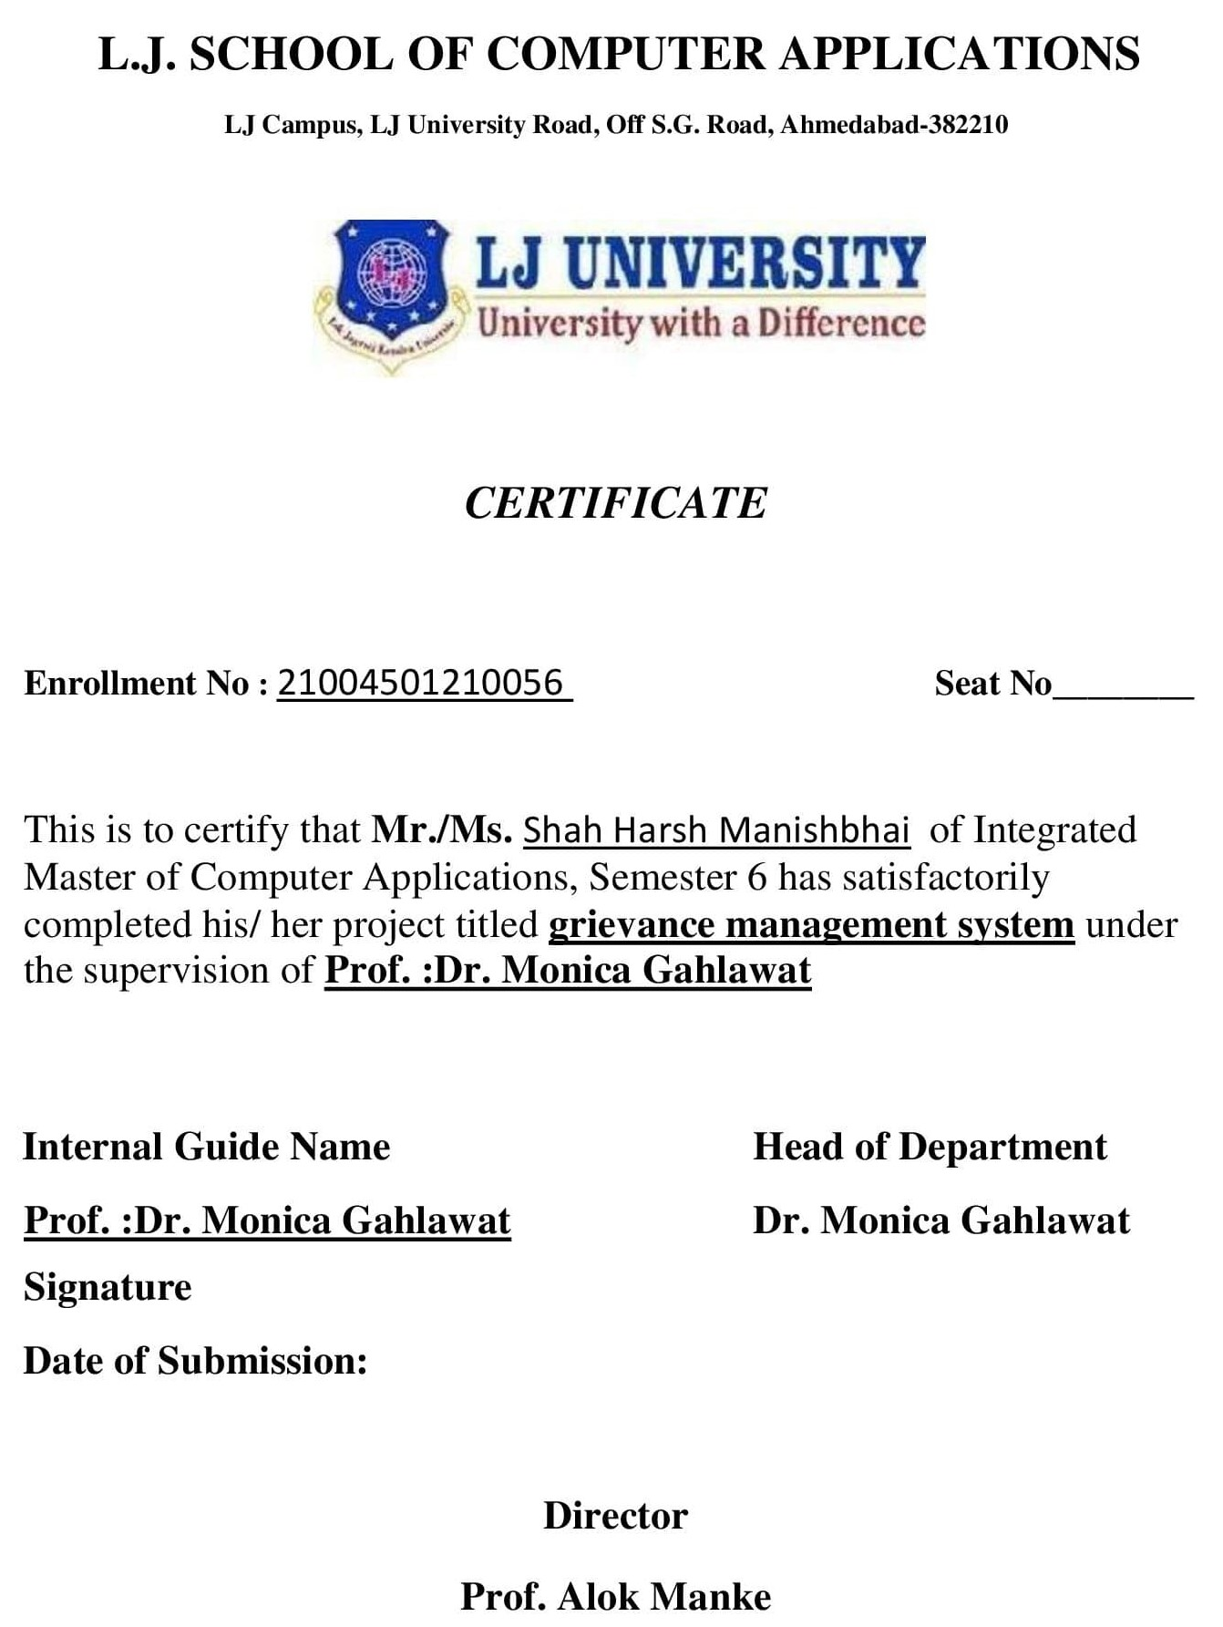

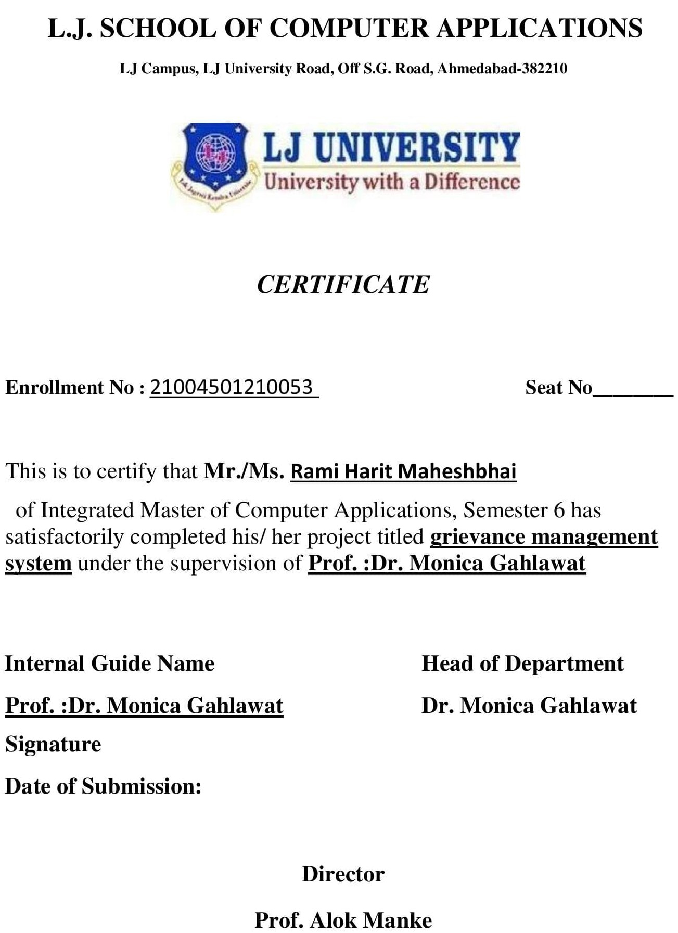

Table of Contents

1. Introduction 6

1.1. Existing System 6

1.2. Need for the New System 8

1.3. Objective of the New System 8

1.4. Problem Definition 9

1.5. Core Components 9

1.6. Project Profile 11

1.7. Assumptions and Constraints 11

1.8. Advantages and Limitations of the Proposed System 12

1.9. Proposed Timeline Chart 13

2. Requirement Determination & Analysis 14

2.1. Requirement Determination 14

2.2. Targeted Users 14

3. System Design 15

3.1. Use Case Diagram 15

3.2. Class Diagram 16

3.3. Interaction Diagram 16

3.4. Activity Diagram 17

3.5. Data Dictionary 18

4. Development 23

4.1. Coding Standards 23

5. Agile Documentation 47

5.1. Agile Project Charter 47

5.2. Agile Road Map 48

5.3. Agile Project Plan 49

5.4. Agile User Story ( Minimum 3 Tasks) 49

5.5. Agile Release Plan 50

5.6. Agile Sprint Backlog 50

5.7. Agile Test Plan 51

5.8. Earned-value and burn charts 51

6. Proposed Enhancements 52

7. Conclusion 52

8. Bibliography 52

# Introduction

***The structure for handling and resolving complaints at educational institutions is described in the document on the student grievance system. It outlines the processes via which students can file complaints, concerns, or problems they run into while pursuing their education. This document is an essential tool for guaranteeing responsibility, fairness, and transparency when addressing complaints, creating an environment that is favorable for learning for all parties concerned. It outlines the roles and responsibilities of different parties in the effective and efficient resolution of conflicts, including students, professors, and administrative personnel.***

***Student Grievance System: Project Focus***

***Within the field of education, and especially in colleges and universities, the student grievance system is essential to preserving peace and promoting an environment that is conducive to learning. With the help of this project, students will have a formal avenue to voice their concerns and seek solutions for issues they may encounter while enrolled in college. Educational institutions can maintain their commitment to student welfare and guarantee that concerns are handled swiftly and fairly by putting in place clear procedures and systems for grievance resolution. Also, putting in place a productive student grievance system improves institutional procedures and policies generally, which raises the standard of instruction delivered while also fostering trust and transparency.***

## Existing System

***1.Submission of Grievances:***

***Through internet portals, students can file grievances.***

***Grievances might be related to illegal behavior, inequality, academic difficulties, or any other issues that have an impact on the student's experience.***

***2.First Assessment:***

***The system forwards a grievance to the appropriate authority—typically a faculty member or administrative staff member—as soon as it is received.***

***To determine the grievance's nature, severity and authority, the designated authority examines it.***

***3.Examining and Documentation:***

***Should the grievance require additional inquiry, the designated authority makes inquiries, gathers proof, and records conclusions.***

***A grievance's specifics, the investigation's course, and any subsequent actions are all documented.***

***4.Resolution Plan:***

***The designated authority makes a grievance resolution proposal after conducting an investigation.***

***Corrective measures, mediation sessions, disciplinary proceedings, or policy changes could all be part of the suggested resolution.***

***5.Review and Approval:***

***Higher authorities, including grievance committees, deans, and department heads, assess the proposed settlement.***

***If the suggested resolution complies with institutional rules and procedures, it is approved.***

***6.Interaction with the student:***

***The results of the grievance procedure are communicated to the student.***

***This notification contains information about the resolution, any steps that were done, and channels for additional raising the level in the event that the result is not satisfactory.***

***7.Execution and Follow-up:***

***The resolution is carried out if it calls for particular measures or modifications, such reevaluating grades or putting new regulations into place.***

***Follow-up protocols guarantee that grievances are adequately addressed and that recurrences are avoided when resolutions are put into place.***

***8.Closure and Feedback:***

***Formally, the grievance matter is closed, and all additional proof is preserved.***

***Feedback from students on their grievance procedure experiences is welcome and helps guide efforts towards ongoing improvement.***

## Need for the New System

***The current student grievance system, while functioning, has various issues and limitations that highlight the need for a new approach. First, the current system may be inefficient due to human operations, resulting in grievance resolution delays and potential backlog accumulation. Furthermore, there may be variations in handling grievances across different departments or campuses, resulting in apparent injustice or inequity in outcomes. Furthermore, the existing system's lack of openness may foster distrust among students and stakeholders, impeding the creation of a helpful and conducive learning environment.Furthermore, the current system may find it difficult to adjust and adequately handle new needs when educational institutions develop and encounter new difficulties including a greater range of students and complex grievances. Therefore, in order to address these issues, improve accountability and transparency, expedite the settlement of student complaints, and guarantee a fair and timely education for all parties concerned, a new approach is necessary.***

## Objective of the New System

***The new student grievance system aims to improve the overall efficacy and efficiency of the grievance resolution processes while addressing the issues found in the current system. Among these goals are:***

***1.Streamlining Procedures: By automating manual processes including grievance submission, routing, and tracking, the new system seeks to streamline the grievance processing procedure. The use of established workflows and procedures by the system guarantees uniformity and minimizes grievance resolution delays, thereby enhancing overall process efficiency.***

***2.Improving Accountability and Transparency: Two important features of the new system are accountability and transparency. Increased transparency into the grievance process can benefit stakeholders by giving them access to real-time updates on the status of complaints and the measures taken. This openness guarantees that choices are made fairly and objectively while also fostering trust among stakeholders and students.***

***3.Reducing Information Latency: The new system's automated warnings and notifications help reduce information latency, which can cause delays in communication and decision-making. The system reduces information latency and speeds up grievance resolution by enabling prompt contact between parties involved in the process.***

***4.Enhancing Accessibility: The new system places a high priority on accessibility by providing a number of avenues for accessing and submitting grievances, including mobile applications and web portals. This accessibility promotes inclusivity and convenience by guaranteeing that students, regardless of location or time zone, may simply register concerns and track their progress.***

***5.Improving Data Accuracy and Analysis: To enable trend analysis and educated decision-making in grievance resolution, data accuracy is critical. The new system minimizes errors and inconsistencies in grievance records by incorporating procedures for data validation and integrity checks. Furthermore, it offers instruments for scrutinizing grievance data in order to detect patterns, underlying reasons, and opportunities for enhancement, facilitating preemptive actions to avert reoccurring problems.***

***6.Encouraging Continuous development: The goals of the new system incorporate continuous development. The system allows institutions to identify areas for improvement and implement iterative improvements over time, ensuring that the system remains responsive to changing needs and challenges. It does this by gathering feedback about the grievance resolution process from stakeholders and students.***

***The new student grievance system's goals are largely in line with resolving the shortcomings of the current one. It seeks to improve the effectiveness, efficiency, and transparency of the grievance resolution procedures, which will ultimately improve the educational experience for all parties.***

## Problem Definition

***The goal of the suggested approach is to solve the shortcomings and inefficiencies of the current procedure used by educational institutions to handle student grievances. It includes, in particular, the creation and deployment of an automated grievance management system that standardizes and expedites the grievance submission, tracking, and resolution process. This approach will strengthen accountability, guarantee prompt issue resolution, promote open communication, and offer data-driven insights for ongoing development. Creating user-friendly grievance submission interfaces for students, setting up internal stakeholder mechanisms for grievance review and resolution, and incorporating capabilities for data analysis and reporting to facilitate well-informed decision-making are all included in the scope.***

## Core Components

***The following basic modules make up the proposed student grievance system; they are all designed to handle particular components of the grievance resolution process and to be in accordance with the goals specified in the problem definition:***

***1.Module for Filing Grievances:***

***The goal is to improve accessibility.With the use of this module, students can file complaints via web portals. The technology guarantees student accessibility by offering various routes for submission, enabling them to quickly file grievances from any location at any time.***

***2.Module for Workflow Management:***

***Goal: Simplifying Procedures***

***By automating the tracking and routing of grievances, the workflow management module makes sure that uniform procedures are adhered to. By allocating responsibilities to pertinent authorities, monitoring advancement, and informing interested parties of impending measures, it expedites the grievance resolution process, cutting down on delays and enhancing overall process effectiveness.***

***3.Module of Communication:***

***Goal: Strengthening Accountability and Transparency***

***This module enables open communication amongst stakeholders by giving them up-to-date information on the status of complaints, actions completed, and choices made. By recording all correspondence pertaining to the resolution of grievances, it guarantees accountability and makes it possible for interested parties to monitor the developments and results of their complaints.***

***4.Module for Data Analysis and Management:***

***Goal: Increasing the Accuracy and Analysis of Data***

***Through validation tests and data governance standards, the data management and analysis module centralizes grievance data while guaranteeing correctness and integrity. It offers resources for examining grievance data in order to spot patterns, underlying issues, and potential improvement areas. This module facilitates proactive steps to address reoccurring issues and continual improvement initiatives by providing data-driven decision-making.***

***5.Feedback and Enhancements Module:***

***Goal: Encouraging Ongoing Improvement***

***Feedback regarding students' and stakeholders' experiences with the grievance resolution procedure is gathered in this module. It includes systems for monitoring the application of feedback-driven modifications, collecting ideas for enhancement, and assessing satisfaction levels. Through the promotion of an improvement-oriented culture, this module guarantees that the system continues to adapt to changing requirements.***

***Through the integration of these fundamental modules, the suggested student grievance system tackles the goals of augmenting accessibility, rationalizing procedures, elevating openness and accountability, refining data precision and analysis, and promoting ongoing enhancement. These modules work together to create a thorough framework for handling complaints in educational institutions in an efficient and effective manner, which will eventually benefit all parties engaged in the educational process.***

## Project Profile

***The Student Grievance System project profile***

***Title of Project: Student Grievance System***

***Project Duration: 4 months***

***Project Objectives: The project's goals are to guarantee data accuracy, increase accessibility, improve transparency, and streamline the grievance resolution process.***

***Project Scope: It includes creating an automated grievance management system, providing training, conducting pilot testing, and implementing it fully.***

***Project Deliverables: Deliverables from the project include a functional system, a report of project, and a deployment schedule.***

***Project Team: Kanzariya Kanji,Harit Rami,Shah Harsh***

***Project Stakeholders: Students, Faculty,Administrators.***

## Assumptions and Constraints

***Assumptions:***

***1.Support from Stakeholders: It is expected that the student grievance system's implementation will be actively supported and participated in by stakeholders, such as academics, administrative staff, and students.***

***2.Technical Infrastructure: It is anticipated that the system's development, deployment, and operation will be supported by the availability of the technical infrastructure, which includes servers, network resources, and software tools.***

***3.Data Availability: It is expected that pertinent data, including grievance records from the past, shall be easily accessible and properly maintained for the purposes of system development and testing.***

***4.Regulatory Compliance: It is planned that the system would abide by all relevant data protection rules and regulations, guaranteeing compliance at all stages of development and operation.***

***Constraints:***

***1.Semester-based Routing: The Head of Department (HOD) of the relevant semester should automatically receive complaints. For example, if a student is in the 5th semester, their complaint should be directed to the HOD of the 5th semester.***

***2.Verification of Authorization: Only students who are enrolled in that semester at this time should be able submit complaints about it. This verifies that grievances are genuine and coming from involved students.***

***3.Complaint Categorization: Students should be required to classify their complaints according to predetermined categories, such as harassment, administrative problems, or academic difficulties. This facilitates the grievance resolution procedure's simplification...***

***4.Proof Requirement: If necessary, students should be forced to submit witness statements, emails, screenshots, or other supporting documentation with their complaints.***

***5.Feedback: Providing a feedback option so that students can offer their opinions on the resolution procedure and result. This will enable the grievance management system to be improved over time.***

## Advantages and Limitations of the Proposed System

***Advantages of the Proposed System:***

***1.Efficiency Gains: By automating manual operations, the suggested system reduces the time it takes to resolve grievances and the amount of backlog it accumulates. This helps to solve the problem of grievance resolution delays.***

***2.Enhanced Transparency: The system addresses issues about fairness and inconsistent grievance treatment by fostering transparency and accountability through real-time updates and documentation of all grievance-related actions.***

***3.Enhanced Accessibility: By providing a variety of avenues for the reporting and monitoring of grievances, such as web portals, the system improves accessibility for students, guaranteeing that grievances can be simply raised and tracked from any location.***

***4.Data Accuracy and Analysis: The system addresses the issue of data discrepancies and the absence of actionable insights in the previous system by centralizing grievance data and offering tools for analysis. This guarantees data accuracy and promotes informed decision-making and continual improvement.***

***Limitations of the Proposed System:***

***1.Internet Dependency: In order to operate and provide access, the suggested system might need to be online. When there is insufficient or inconsistent internet access, users can have trouble using the system or filing complaints, which could make it more difficult to meet corporate goals.***

***2.Technical Problems: Although every effort is made to guarantee system resilience, there is always a chance that errors, outages, or incompatibilities with various devices or browsers will occur. These problems will impact the system's functionality and user experience.***

***3.User Adoption Challenges: The efficiency of the suggested approach in resolving complaints and accomplishing business goals may be hampered if stakeholders, in particular students and teachers, are reluctant to adapt or inexperienced with technology.***

***4.Privacy and Security Concerns: The system's dependence on digital data storage and communication methods may give rise to privacy and security concerns, particularly with respect to sensitive grievance-related data. If these issues are not sufficiently addressed, the system's ability to handle complaints effectively may be jeopardized and trust may be eroded.***

## Proposed Timeline Chart

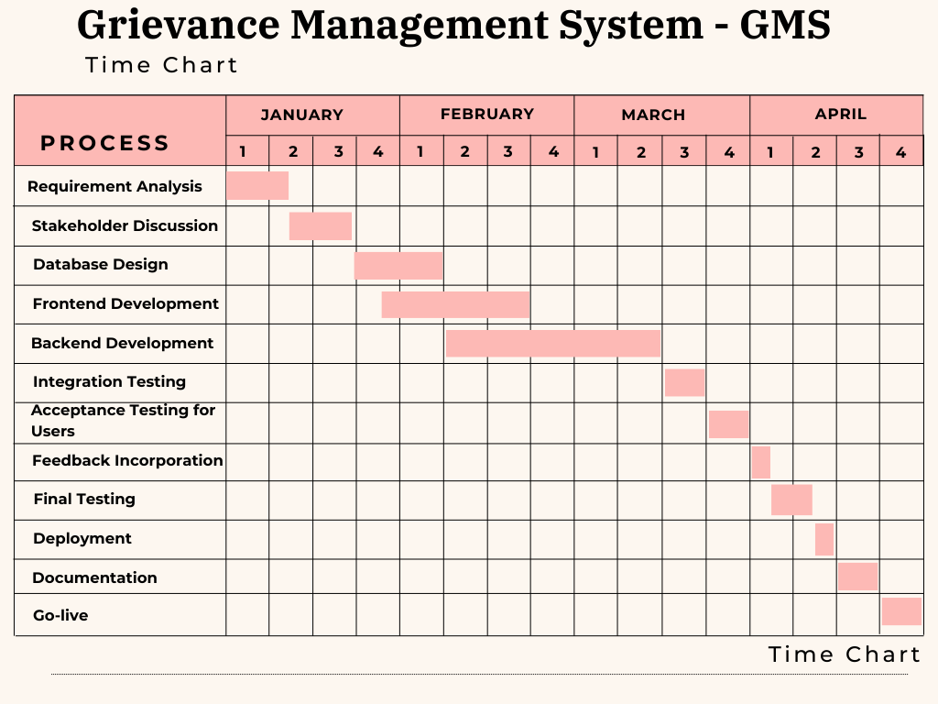

# Requirement Determination & Analysis

## Requirement Determination

***1.Interviews with Stakeholders: In order to get their opinions on the current grievance resolution procedure and their suggestions for enhancements, important stakeholders such as students, instructors, administrative personnel, and senior management were questioned. These interviews yielded insightful information on the problems, difficulties, and features that the suggested system should have.***

***2.Focused Group Discussions: To get deeper into particular issues pertaining to grievance resolution, focused group discussions were held with representative groups of stakeholders. These conversations facilitated participatory idea sharing, the discovery of recurring themes, and the development of consensus around the most important criteria.***

***3.Surveys & Questionnaires: In order to gather quantitative data and verify the conclusions drawn from group discussions and interviews, questionnaires and surveys were sent to a larger group of stakeholders. With relation to the grievance resolution procedure and prospective system improvements, these tools assisted in quantifying stakeholder preferences, priorities, and satisfaction levels.***

***4.Evaluation of Current paperwork: In order to comprehend the current condition of grievance management procedures and pinpoint opportunities for improvement, existing paperwork, including policy documents, procedural manuals, and prior grievance records, was examined. This review offered insightful background information that helped define needs and guide talks with stakeholders.***

***5.Research on Best Practices and Benchmarking: In order to find industry norms, new trends, and cutting-edge features that may be added to the suggested system, studies on best practices in student management and grievance resolution as well as benchmarking were carried out. This outside viewpoint ensured that the suggested system complies with industry standards and future requirements, adding value to the requirements gathering process.***

***Through the use of these many approaches, the requirements determination process guaranteed a thorough grasp of stakeholder demands, preferences, and pain areas, which made it easier to create a solid and user-focused student grievance system.***

## Targeted Users

***Students:***

***Role: File grievances, monitor grievance progress and provide feedback on the resolution procedure.***

***Faculty Members:***

***Participate in the grievance resolution process, examine and accept student grievances, and offer suggestions and feedback.***

***Administrators:***

***Role: Coordinate and direct the grievance resolution procedure, designate grievances to the relevant staff, and keep tabs on the status of grievances.***

# System Design

## Use Case Diagram

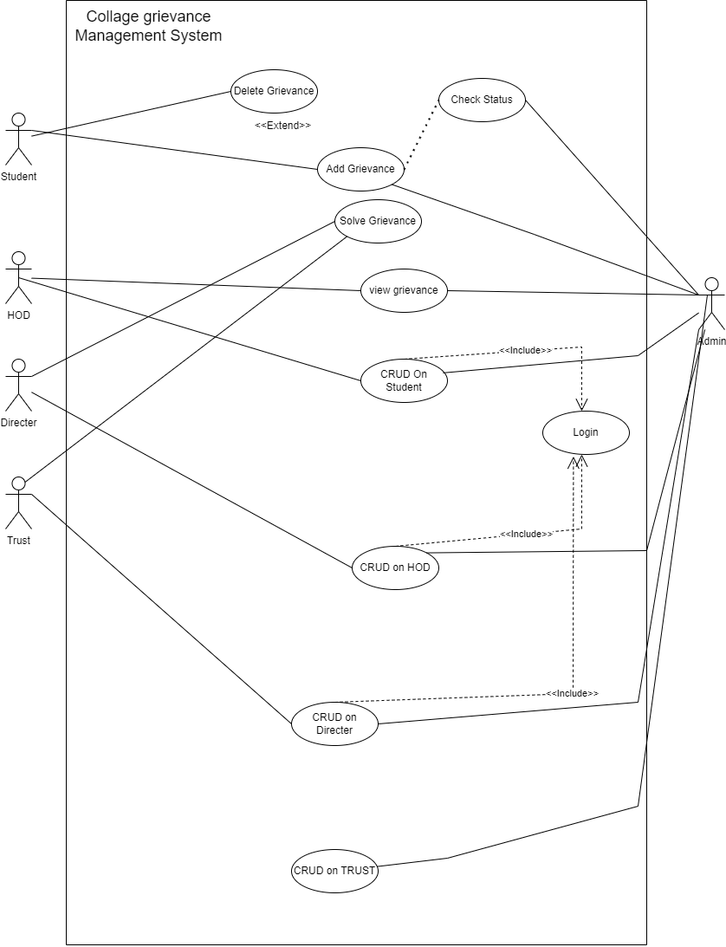

## Class Diagram

I have provided an overview of the class diagram because if we were to create a class diagram using all tables, it might not be properly visible.

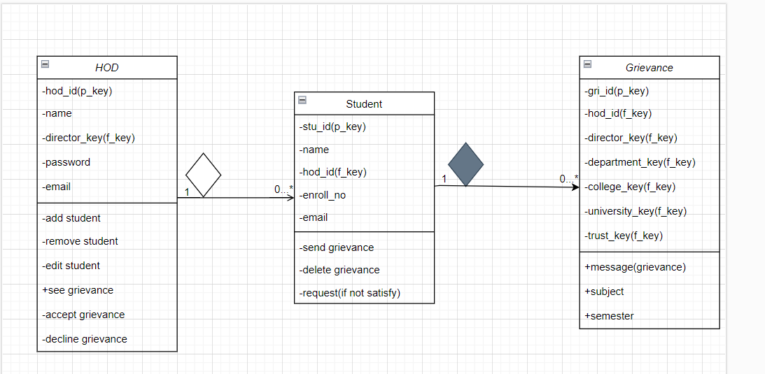

## Interaction Diagram

I have taken 3 tables actions student,hod and main admin in this diagram.

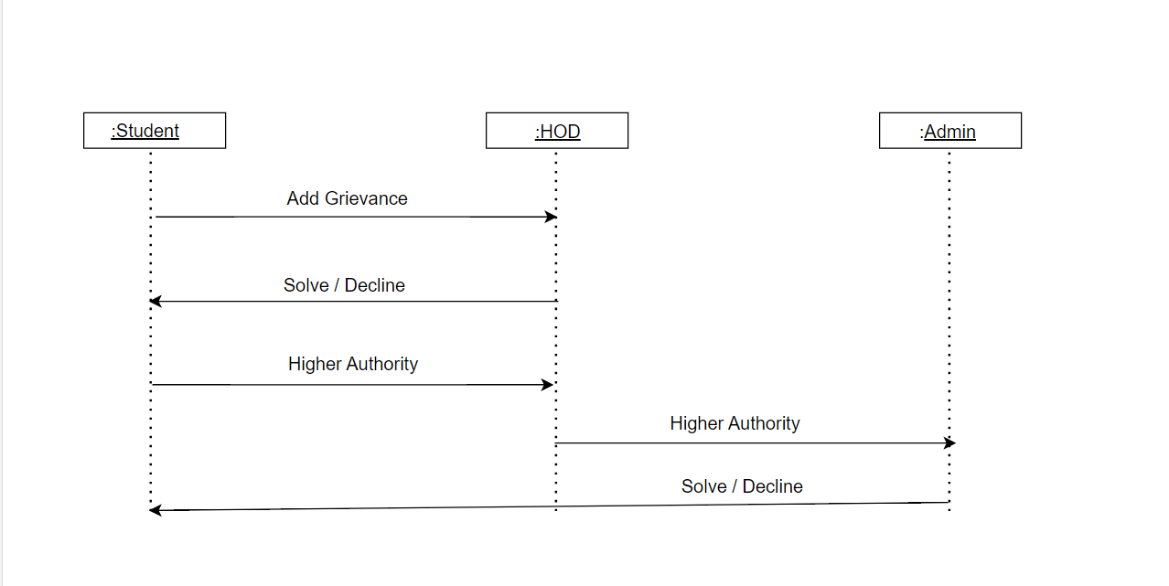

## Activity Diagram

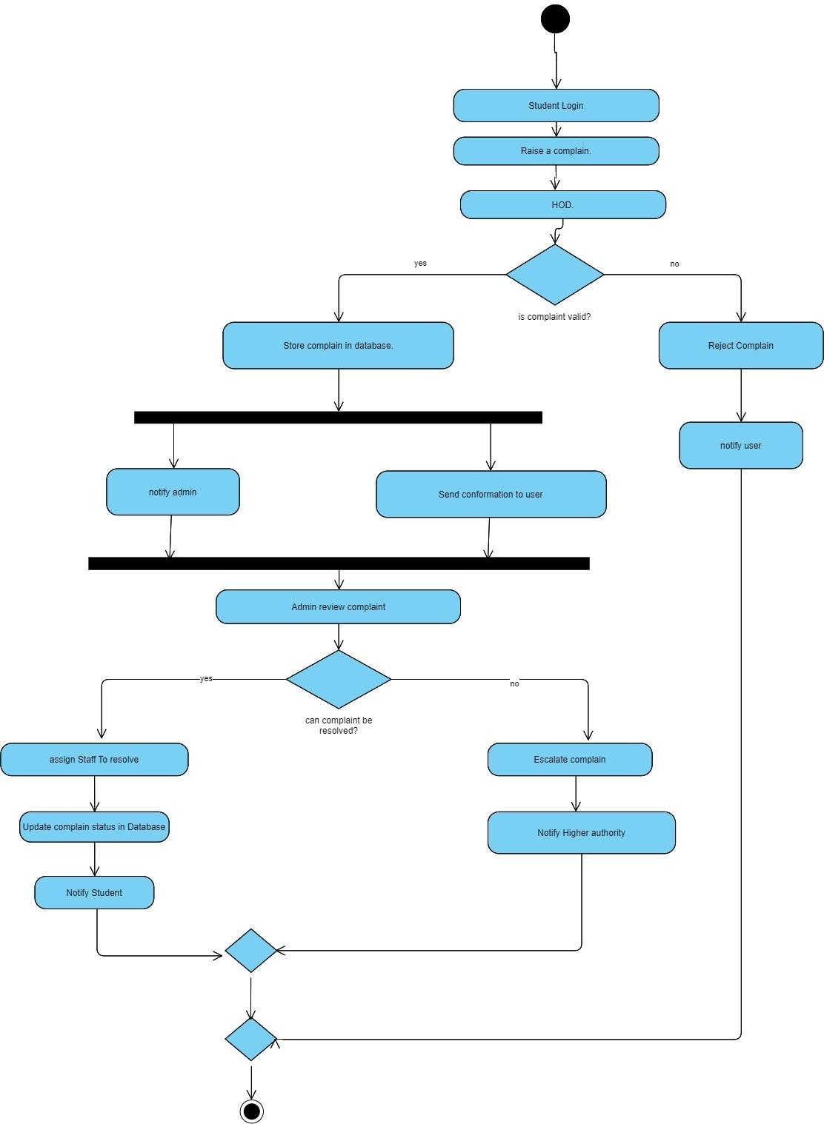

## Data Dictionary

**Table Name:** AdminMaster

**Table Description:** Stores the basic details **Id,** **Name,Password,Email_id** and **Create_at** of each Admin.

| Field Name | Data Type (with Size) | Constraint | Description | Sample Data |
| --- | --- | --- | --- | --- |
| Id | INT, IDENTITY | **Primary Key** | Id of Admin | 2712 |
| Name | VARCHAR(255) | Not Null | Name of Admin | Harit Rami |
| Password | VARCHAR(255) | Not Null | Password of Admin | s@#256 |
| Email_id | VARCHAR(255) | Not Null | Email id of Admin | h56@gmail.com |
| Create_at | DateTime | Not Null | Date and Time | 2024-03-13 17:11 |

**Table Name:**TrustMaster

**Table Description:** Stores the basic details **trust_id,** **gov_reg_id,Name,Password,Email_id and**  **Create_at** of each Trust.

| Field Name | Data Type (with Size) | Constraint | Description | Sample Data |
| --- | --- | --- | --- | --- |
| trust_id | INT, IDENTITY | **Primary Key** | Id of Trust | 271295 |
| gov_reg_id | VARCHAR(255) | Not Null | Government registration id | 03ljku26 |
| Name | VARCHAR(255) | Not Null | Name of Trust | Maulik Satapara |
| Password | VARCHAR(255) | Not Null | Password of Trust | s@#256 |
| Email_id | VARCHAR(255) | Not Null | Email id of Trust | h56@gmail.com |
| Create_at | DateTime | Not Null | Date and Time | 2024-03-13 17:11 |

**Table Name:**UniversityMaster

**Table Description:** Stores the basic details **university_id,**

**university_name,logo,university_code,Password,trust,Email_id and**  **Create_at** of each University.

| Field Name | Data Type (with Size) | Constraint | Description | Sample Data |
| --- | --- | --- | --- | --- |
| university_id | INT, IDENTITY | **Primary Key** | Id of University | 2712562 |
| university_name | VARCHAR(255) | Not Null | Name of University | ljku |
| logo | Image | Null | Image of | Image |
| university_code | VARCHAR(255) | Unique | university code | 2lki2y6 |
| Password | VARCHAR(255) | Not Null | Password of University | s@#256 |
| trust | FOREIGN KEY | NULL | Foreign key of trust | It depends on Primary key |
| Email_id | VARCHAR | Not Null | Email id of University | h56@gmail.com |
| Create_at | DateTime | Not Null | Date and Time | 2024-03-13 17:11 |

**Table Name:**CollegeMaster

**Table Description:** Stores the basic details

**college_id,** **college_name,university_id,Password,Email_id,address_of_college and**  **Create_at** of each College.

| Field Name | Data Type (with Size) | Constraint | Description | Sample Data |
| --- | --- | --- | --- | --- |
| college_id | INT, IDENTITY | **Primary Key** | Id of University | 2712 1421 9924 4563 |
| college_name | VARCHAR(255) | Not Null | Name of **college** | lj institute of computer applications |
| university_id | Foreign Key | Not Null | foreign key of university | It depends on Primary key |
| Password | VARCHAR(255) | Not Null | Password of College | s@#256 |
| address_of_college | VARCHAR(255) | NULL | Address of College | S.G. Highway |
| Email_id | VARCHAR(255) | Not Null | Email id of College | h56@gmail.com |
| Create_at | DateTime | Not Null | Date and Time | 2024-03-13 17:11 |

**Table Name:**DepartmentMaster

**Table Description:** Stores the basic details

**department_id,** **dept_name,college,Password,Email_id and**  **Create_at** of each Department.

| Field Name | Data Type (with Size) | Constraint | Description | Sample Data |
| --- | --- | --- | --- | --- |
| department_id | INT, IDENTITY | **Primary Key** | Id of department | 271212333 |
| dept_name | VARCHAR(255) | Not Null | Name of **department** | IMCA |
| Password | VARCHAR(255) | Not Null | Password of College | s@#256 |
| college | FOREIGN KEY | Null | Foreign key of college | It depends on Primary key |
| Email_id | VARCHAR(255) | Not Null | Email of Department | h56@gmail.com |
| Create_at | DateTime | Not Null | Date and Time | 2024-03-13 17:11 |

**Table Name:DirectorMaster**

**Table Description:** Stores the basic details

**director_id,** **name,department,Password,Email_id and**  **Create_at** of each Director.

| Field Name | Data Type (with Size) | Constraint | Description | Sample Data |
| --- | --- | --- | --- | --- |
| director_id | INT, IDENTITY | **Primary Key** | Id of director | 2712 1421 9924 4563 |
| name | VARCHAR(255) | Not Null | Name of director | Alok Manke Sir |
| department | FOREIGN KEY | Not Null | Foreign key of department | It depends on Primary key |
| Password | VARCHAR(255) | Not Null | Password of Director | s@#256 |
| img | VARCHAR(255) | NULL | Image of director | - |
| Email_id | VARCHAR(255) | Not Null | Email of director | h56@gmail.com |
| Create_at | DateTime | Not Null | Date and Time | 2024-03-13 17:11 |

**Table Name:HODMaster**

**Table Description:** Stores the basic details

**hod_id,** **name,director,Password,Email_id,img and**  **Create_at** of each HOD.

| Field Name | Data Type (with Size) | Constraint | Description | Sample Data |
| --- | --- | --- | --- | --- |
| hod_id | INT, IDENTITY | **Primary Key** | Id of hod | 2712 1421 9924 4563 |
| name | VARCHAR(255) | Not Null | Name of hod | Alok Manke Sir |
| director | FOREIGN KEY | Not Null | Foreign key of  director | It depends on Primary key |
| Password | VARCHAR(255) | Not Null | Password of Hod | s@#256 |
| Email_id | VARCHAR(255) | Not Null | Email of Hod | h56@gmail.com |
| Create_at | DateTime | Not Null | Date and Time | 2024-03-13 17:11 |

**Table Name:StudentMaster**

**Table Description:** Stores the basic details

**stu_id,** **name,hod_id,Password,Email_id and enrollment_no** of each Student.

| Field Name | Data Type (with Size) | Constraint | Description | Sample Data |
| --- | --- | --- | --- | --- |
| stu_id | INT, IDENTITY | **Primary Key** | Id of Student | 2712 1421 9924 4563 |
| name | VARCHAR(255) | Not Null | Name of Student | Alok Manke Sir |
| hod_id | FOREIGN KEY | Not Null | Foreign key of  hod | It depends on Primary key |
| Password | VARCHAR(255) | Not Null | Password of Student | s@#256 |
| enrollment_no | INTEGER(20) | NULL | enrollment number of  Student | 2100401331 |
| Email_id | VARCHAR(255) | Not Null | Email of Student | h56@gmail.com |
| Create_at | DateTime | Not Null | Date and Time | 2024-03-13 17:11 |
| barcode | image | Null | Enrollment Number | 21004501212032 |

**Table Name:GrievanceMaster**

**Table Description:** Stores the basic details

**grievanceId,** **hod_Fk,director_Fk,department_Fk,semester,subject,message,collage_Fk,university_Fkand trust_Fk** of each Grievance.

| Field Name | Data Type (with Size) | Constraint | Description | Sample Data |
| --- | --- | --- | --- | --- |
| grievanceId | INT, IDENTITY | **Primary Key** | Id of **grievanceid** | 154451 |
| hod_Fk | FOREIGN KEY | Null | Foreign key of  hodmaster | It depends on Primary key |
| director_Fk | FOREIGN KEY | Null | Foreign key of  directormaster | It depends on Primary key |
| department_Fk | FOREIGN KEY | Null | Foreign key of  departmentmaster | It depends on Primary key |
| semester | VARCHAR(50) | Not Null | semester of Student | 5th |
| subject | VARCHAR(100) | Null | subject of semester | FCO |
| message | VARCHAR(200) | Not Null | Message of student | water issue |
| collage_Fk | FOREIGN KEY | Null | Foreign key of  collegemaster | It depends on Primary key |
| university_Fk | FOREIGN KEY | Null | Foreign key of  universityMaster | It depends on Primary key |
| trust_Fk | FOREIGN KEY | Null | Foreign key of  trustMaster | It depends on Primary key |
| Create_at | DateTime | Not Null | Date and Time | 2024-03-13 17:11 |

**Table Name:SolveGrievanceMaster**

**Table Description:** Stores the basic details

**solvegrievanceld,** **subject,solution,grievanceId,solver_name,solver_role,solver_emailid,studentId** of each Grievance.

| Field Name | Data Type (with Size) | Constraint | Description | Sample Data |
| --- | --- | --- | --- | --- |
| solvegrievanceld | INT, IDENTITY | **Primary Key** | Id of solve grievanceid | 154451 |
| grievanceId | FOREIGN KEY | Null | Foreign key of  grievancemaster | It depends on Primary key |
| solver_name | VARCHAR(200) | Null | name of grievance  solver | kanji |
| solver_role | VARCHAR(200) | Null | post of grievance  solver | HOD |
| semester | VARCHAR(50) | Not Null | semester of Student | 5th |
| subject | VARCHAR(100) | Null | subject of grievance | water issue |
| solver_emailid | VARCHAR(200) | Not Null | email of grievance  solver | shahres@gmail  .com |
| studentId | FOREIGN KEY | Null | Foreign key of  studentmaster | It depends on Primary key |
| university_Fk | FOREIGN KEY | Null | Foreign key of  universityMaster | It depends on Primary key |
| trust_Fk | FOREIGN KEY | Null | Foreign key of  trustMaster | It depends on Primary key |
| Create_at | DateTime | Not Null | Date and Time | 2024-03-13 17:11 |

# Development

***To guarantee effectiveness and cooperation among team members, a methodical approach was utilized during the creation of the student grievance management system. The project requirements were first carefully examined and broken down into doable tasks. To ensure a balanced workload, each team member was given particular tasks based on their areas of competence and interests. To coordinate activities, talk about progress, and handle problems, regular meetings were conducted. A version control system like Git was used to smoothly handle code contributions in order to aid integration. Practices for continuous integration were put in place to regularly combine separate parts into a single system, enabling the early identification and resolving of issues.***

## Coding Standards

***Following naming conventions and coding guidelines was essential to preserving uniformity and readability across the codebase when the student grievance management system was being developed. The group adhered to industry-standard coding standards, including those set forth by the programming language (Python PEP 8, JavaScript ESLint, for example), which mandated conventions such as modularization, appropriate commenting, and uniform indentation. To improve code uniformity and readability, camelCase naming was also used for variables and functions. Variables, functions, and classes were given meaningful and descriptive names that clearly communicated their functions and purposes. In addition, significant remarks were included when needed to clarify intricate algorithms or give background information for upcoming developers.***

***4.2*** Screen Shots

->Login Admin

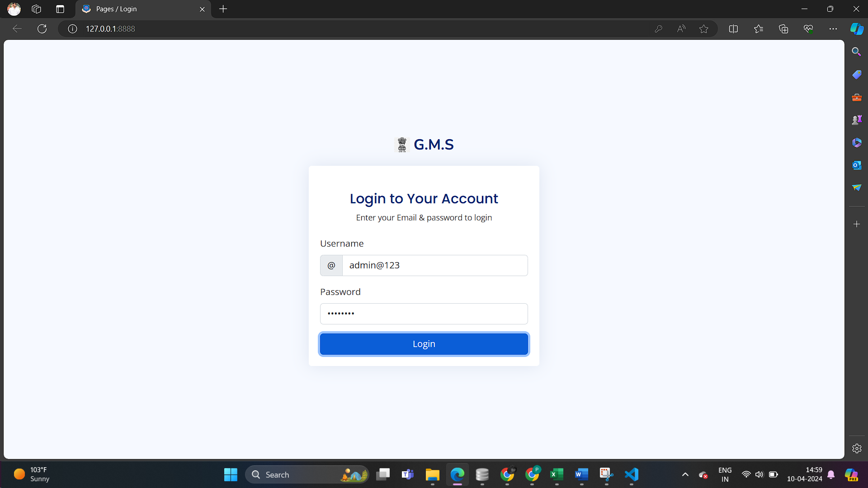

* ***Admin***

***->Home Page Of Admin***

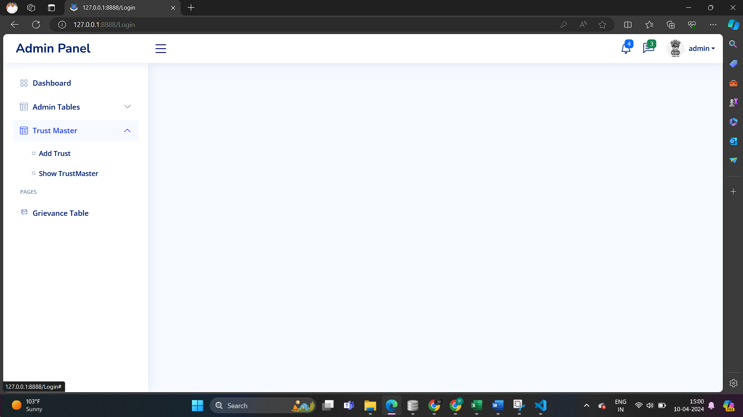

***-> Add Admin Form***

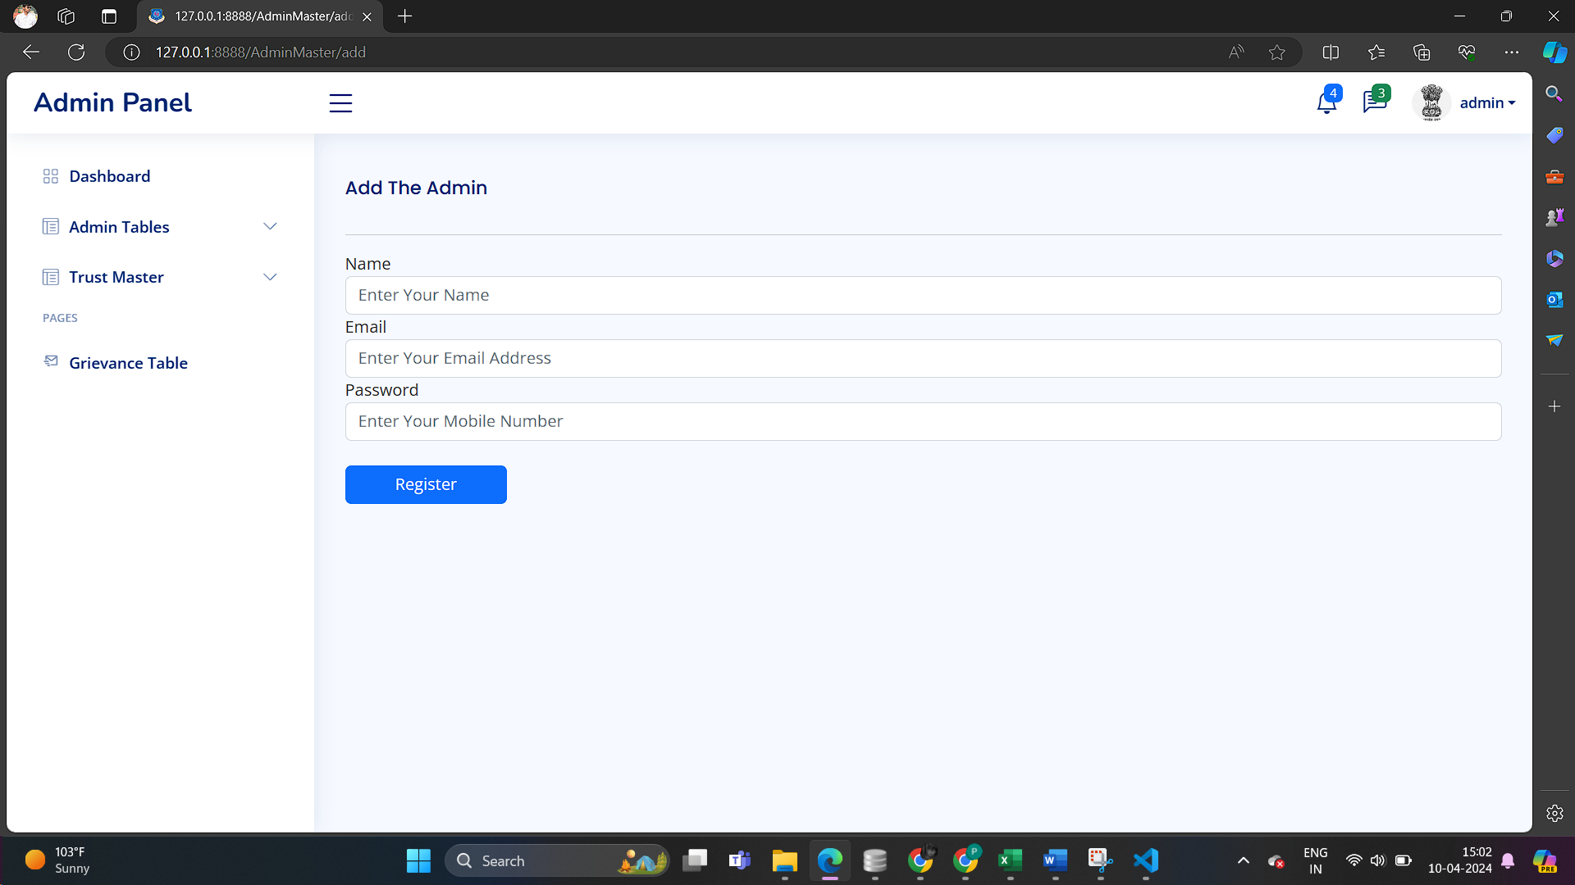

***-> Show Admin List***

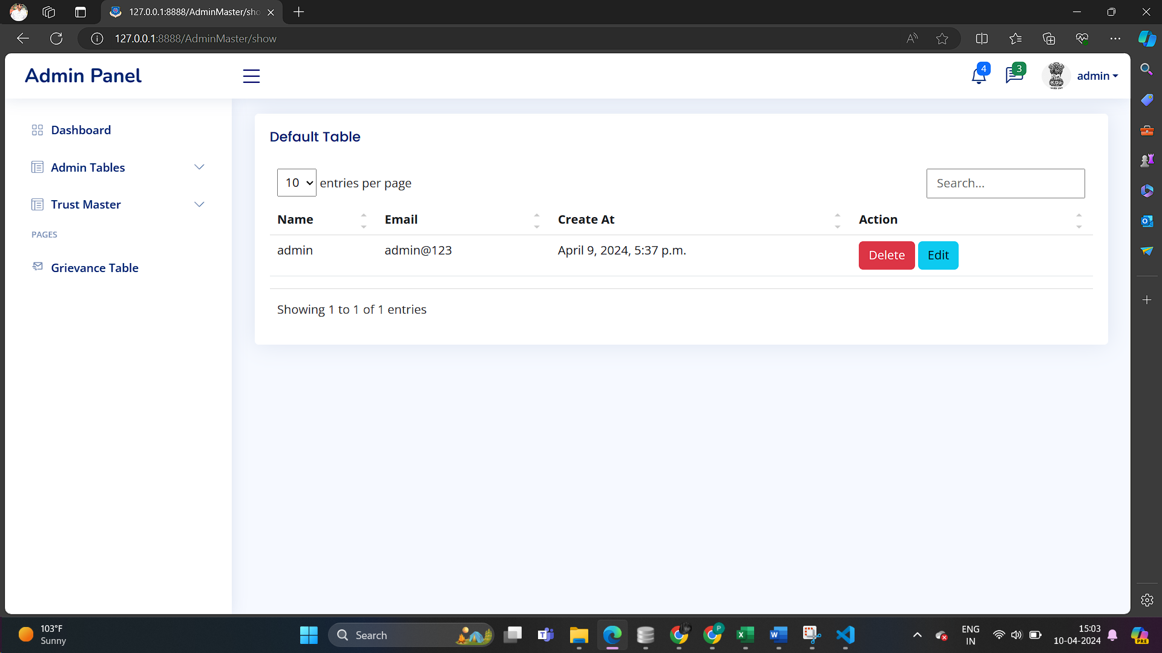

***-> Edit Admin from***

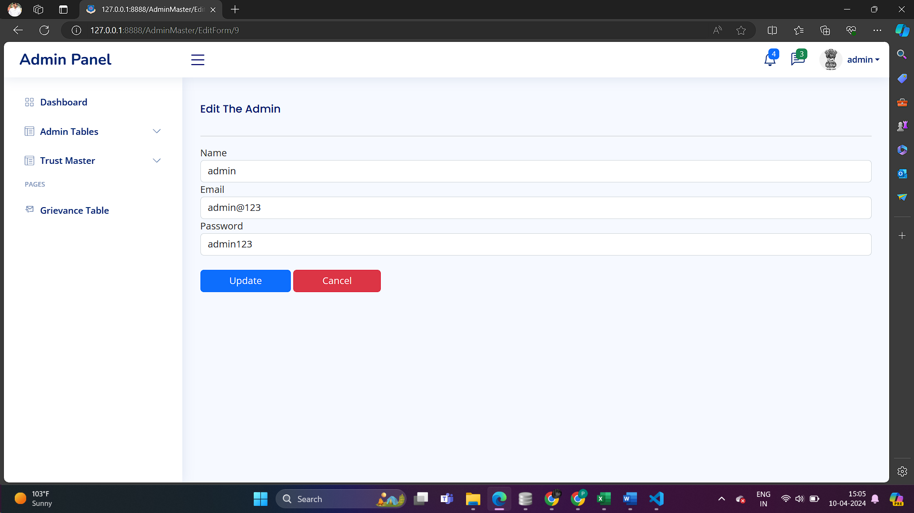

***->Add Trust***

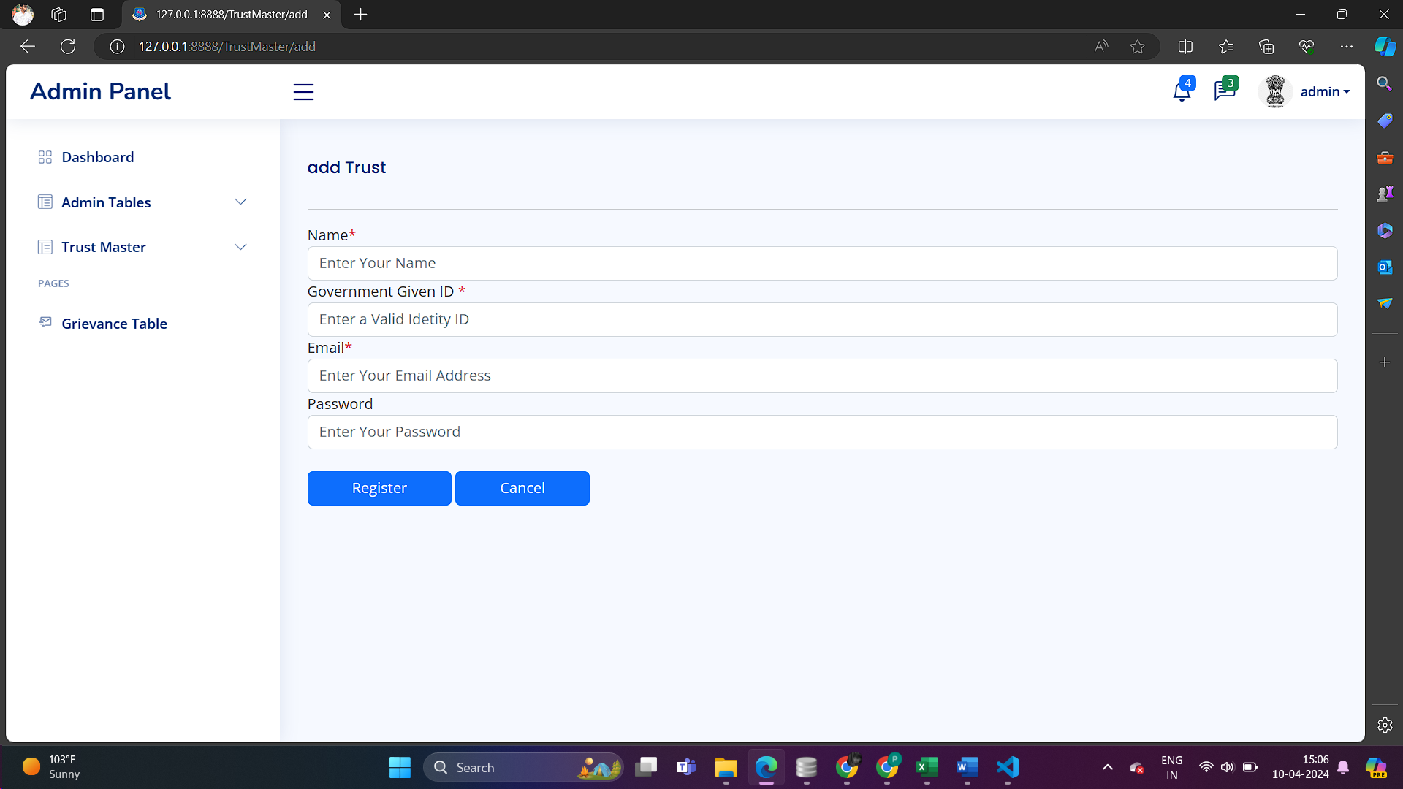

***-> Show Trust List***

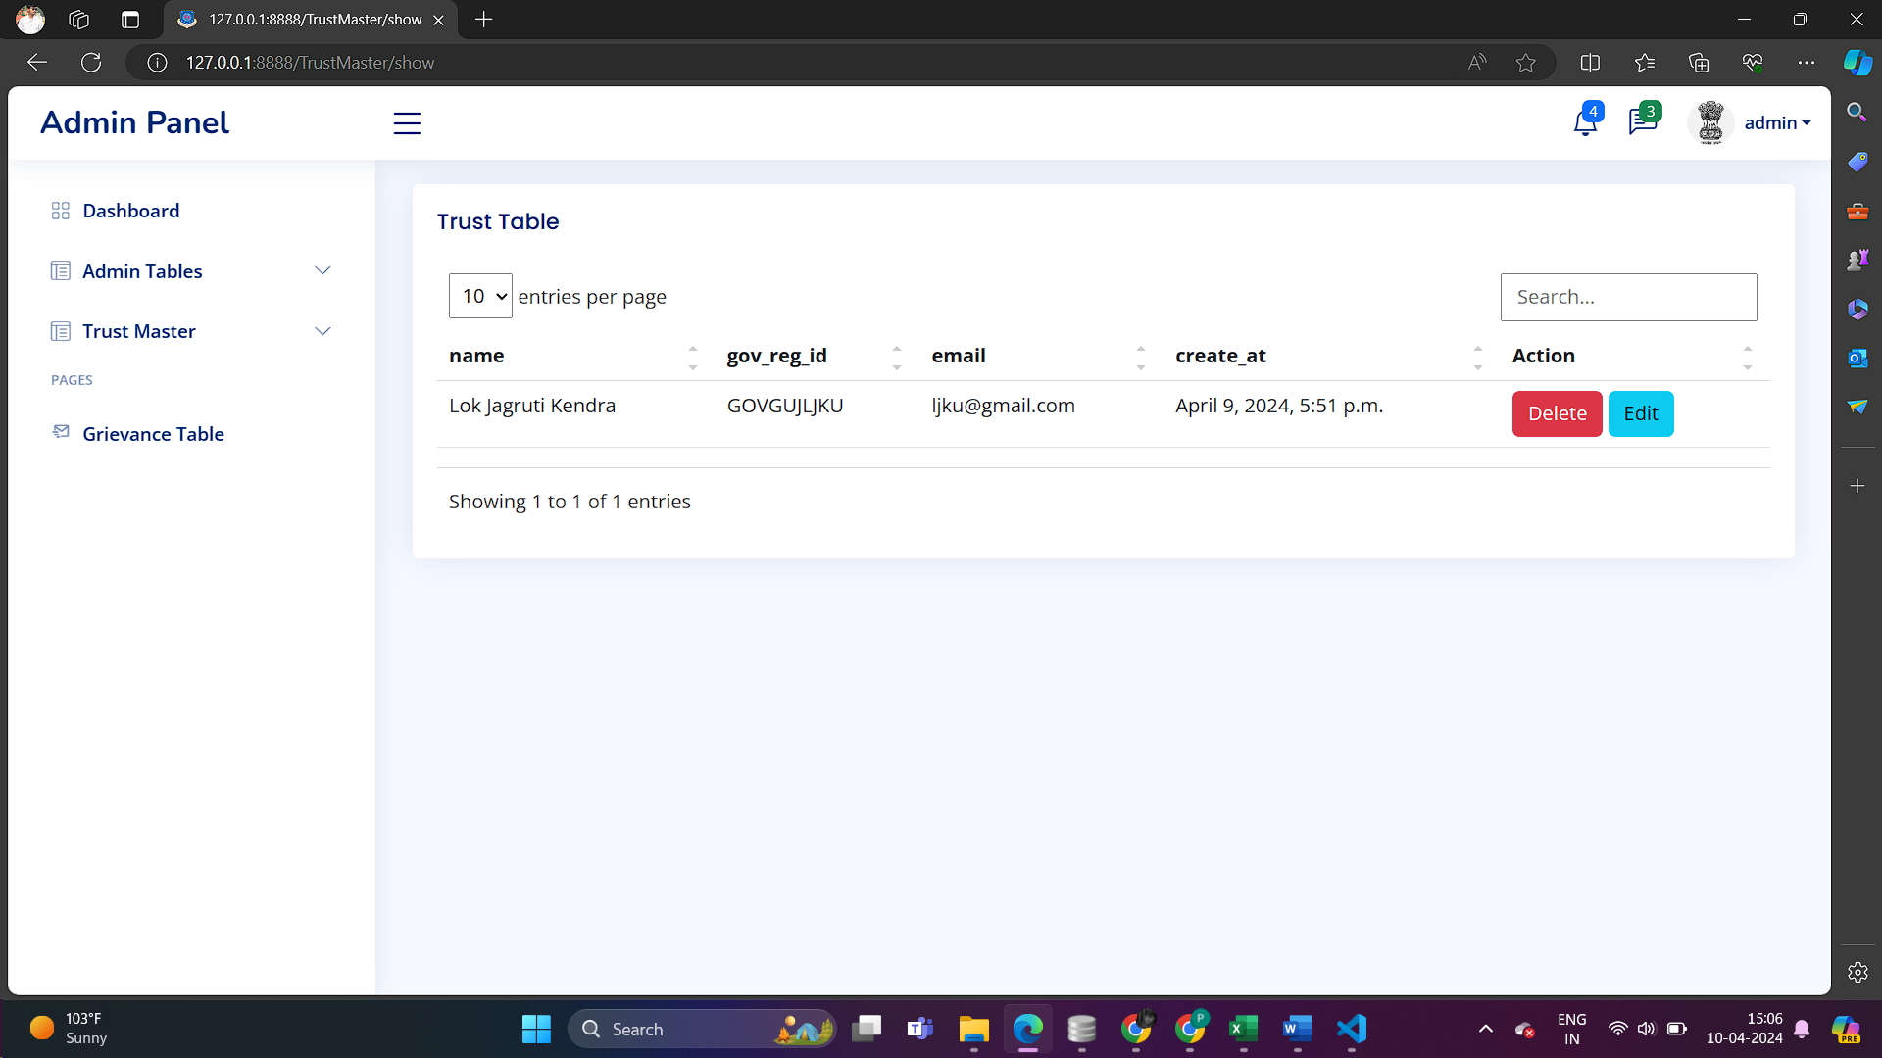

***-> Edit From Of Trust***

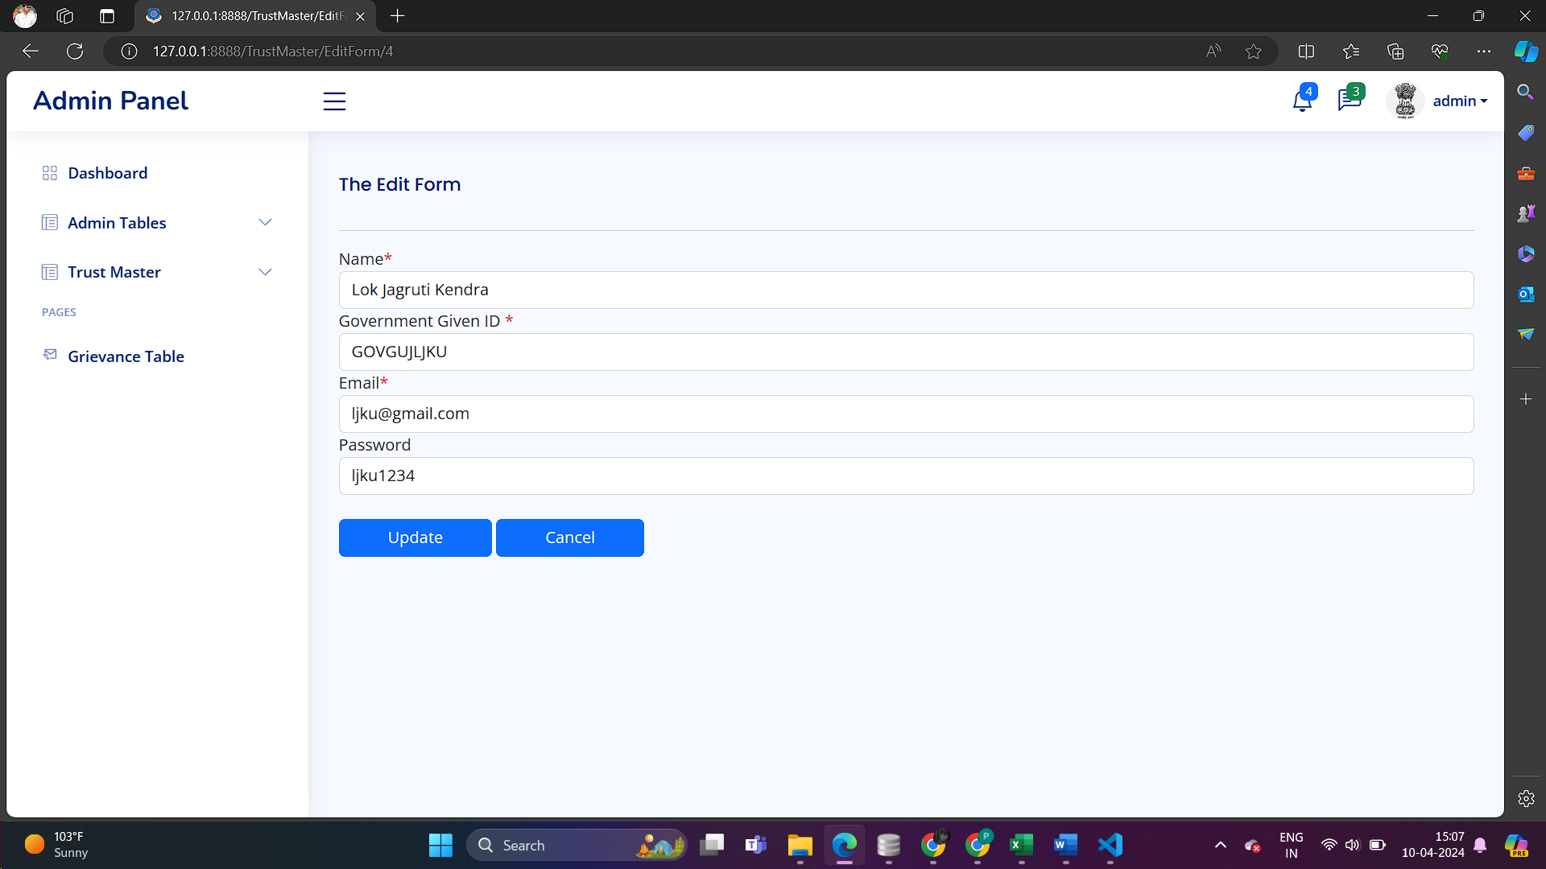

* ***Trust***

***-> Login As a Trust***

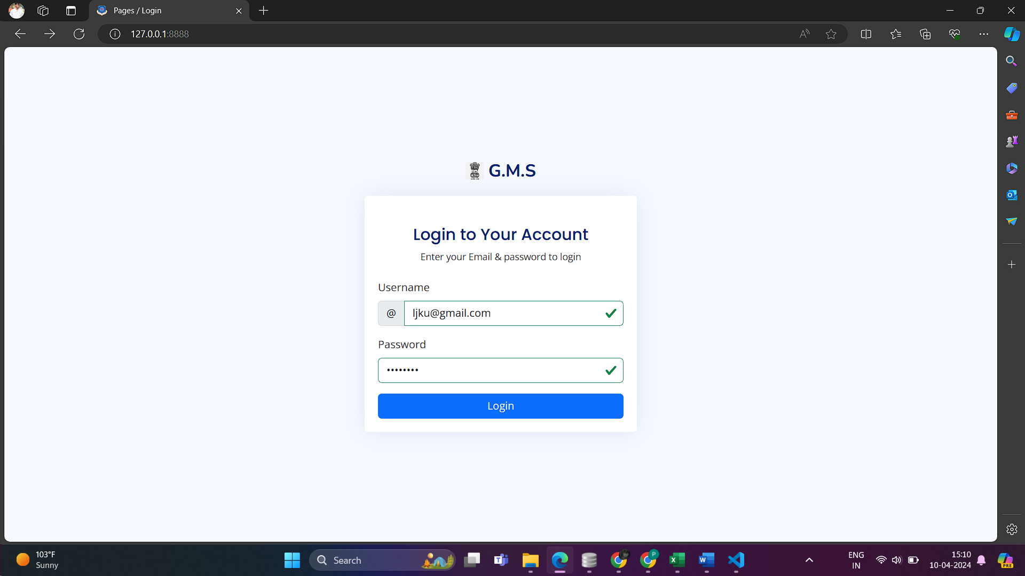

***->*** [*Dashboard*](http://127.0.0.1:8888/home) ***Of Trust***

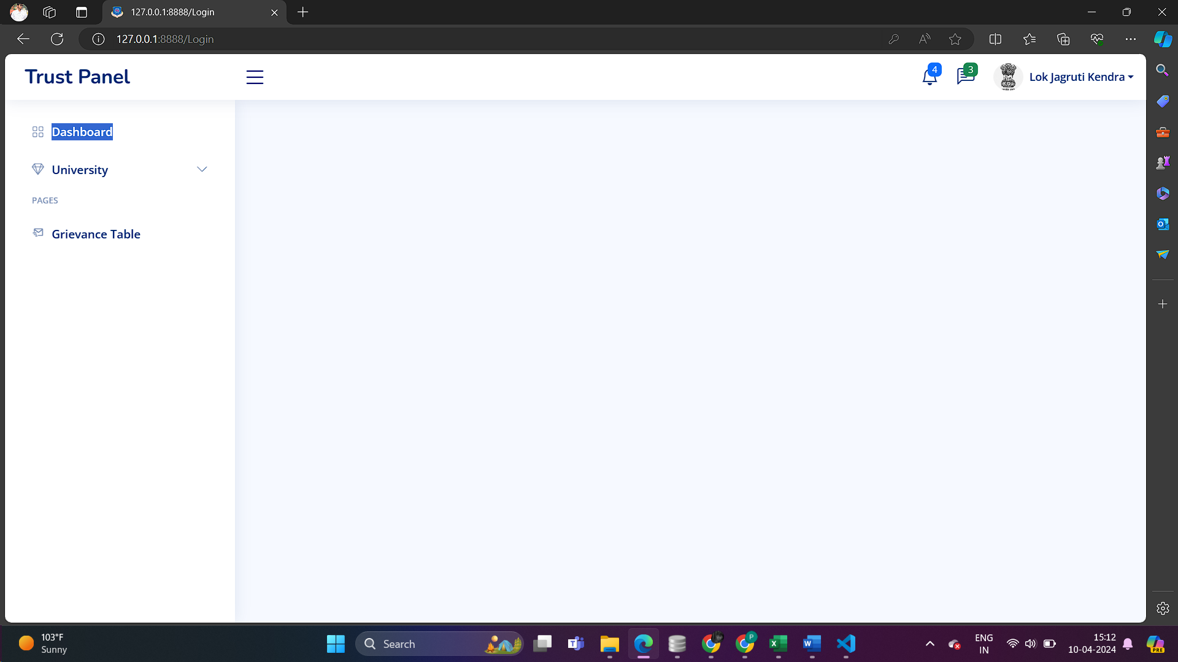

***-> Add University Form***

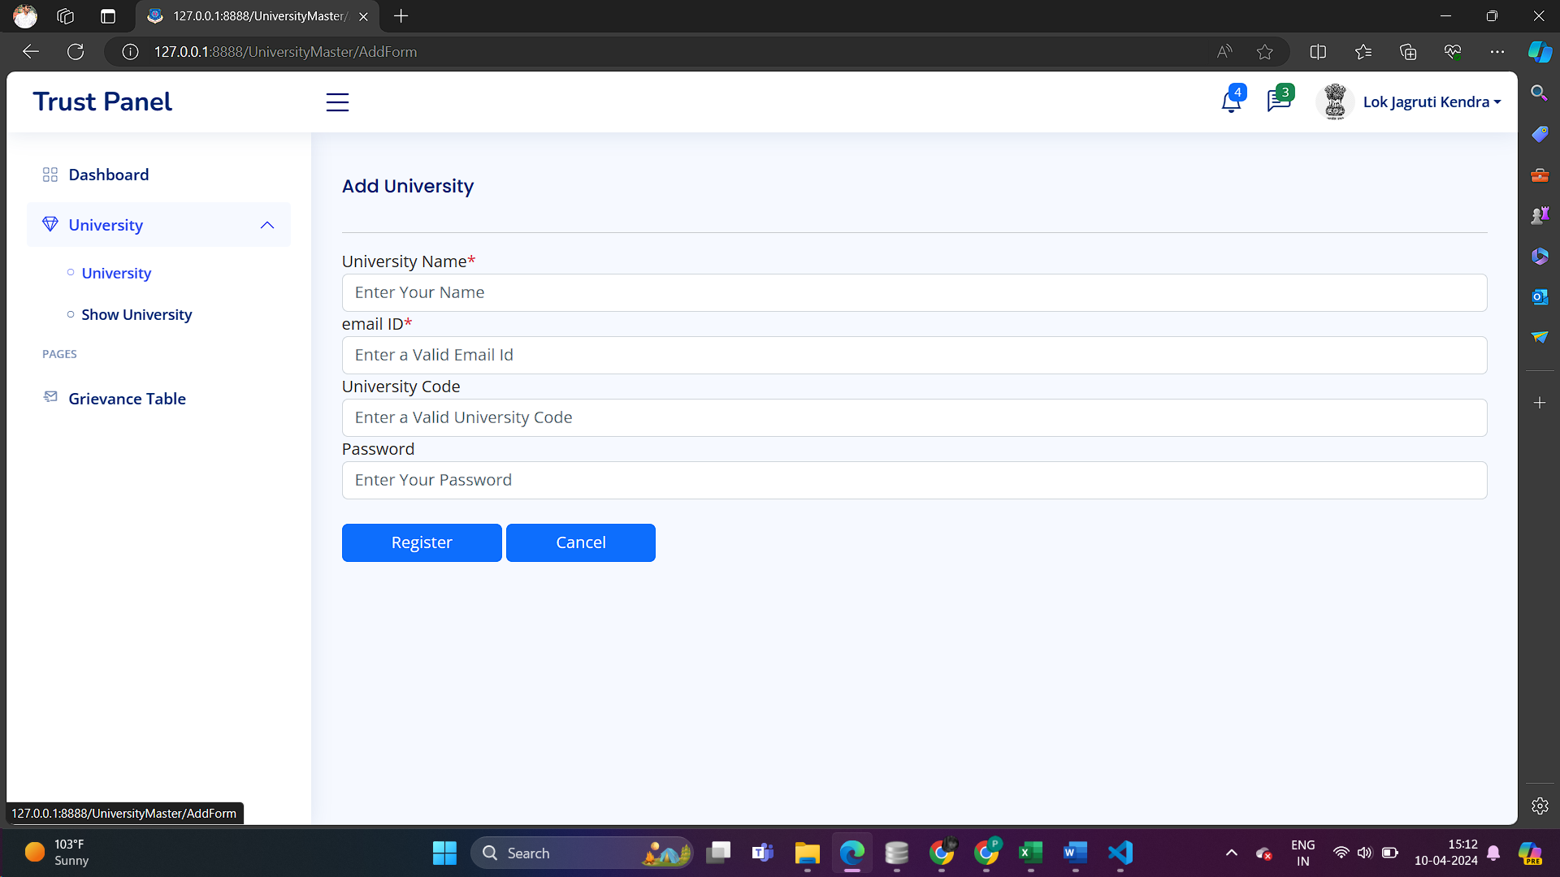

***->Show University Table***

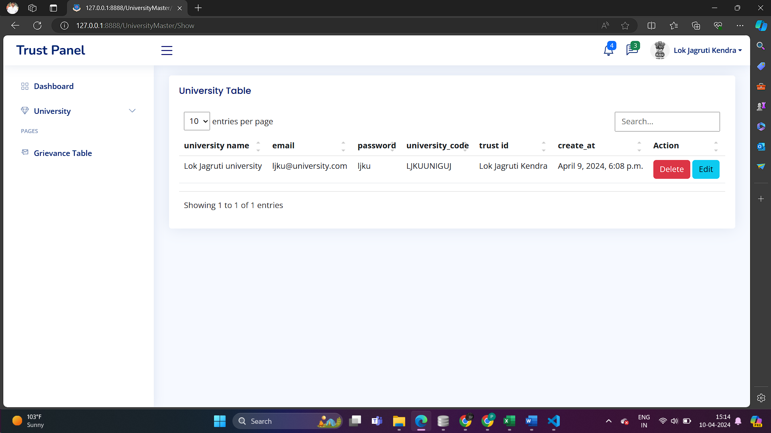

***-> Edit From Of University***

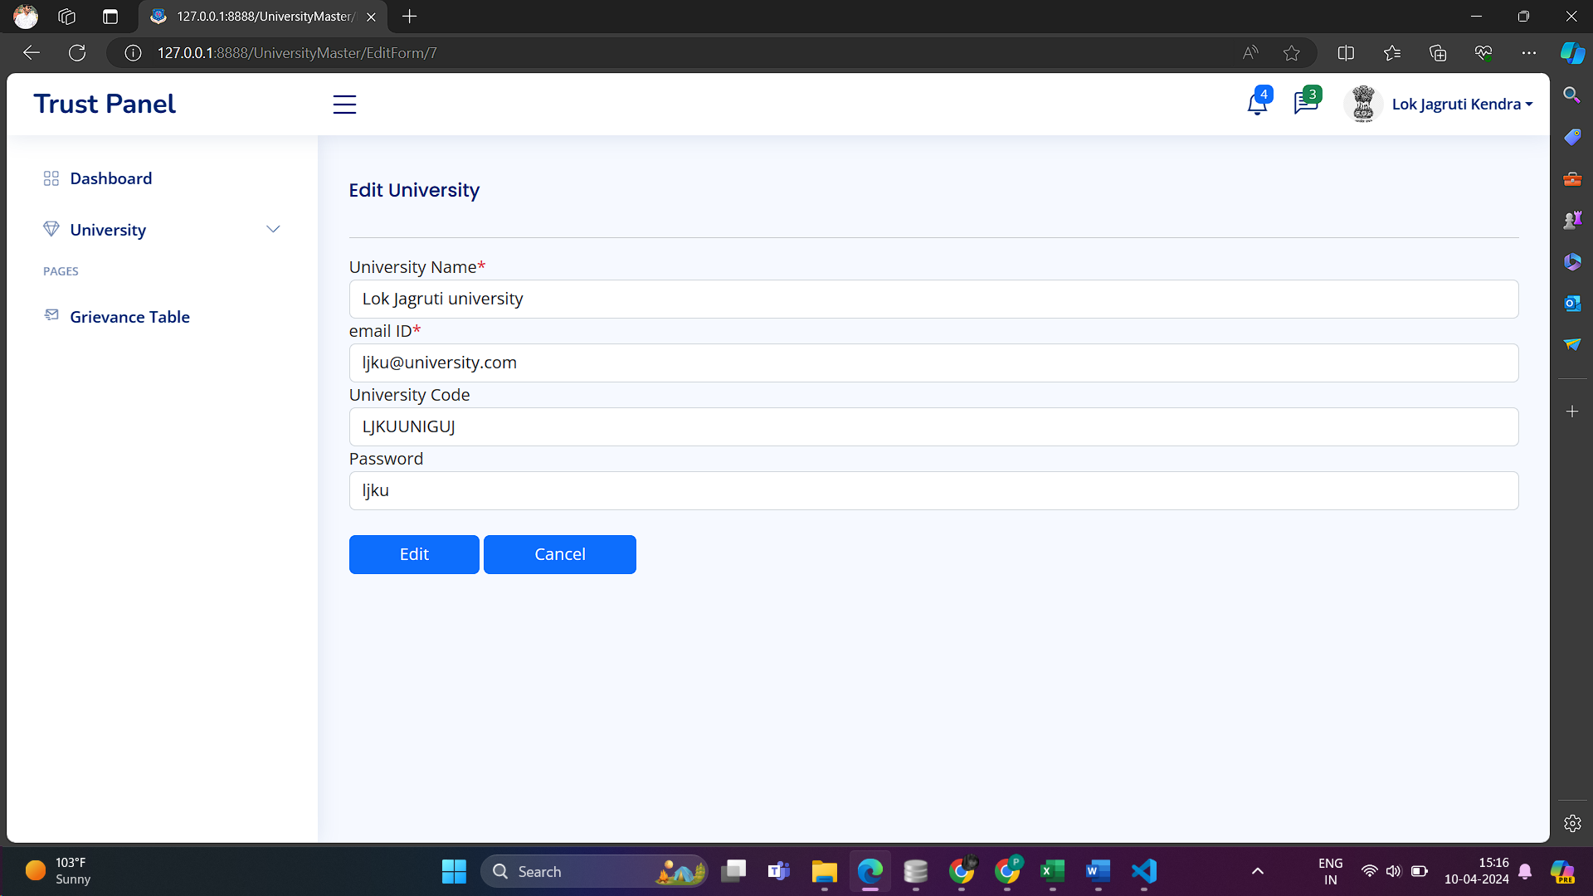

* ***University***

***->Login Of University***

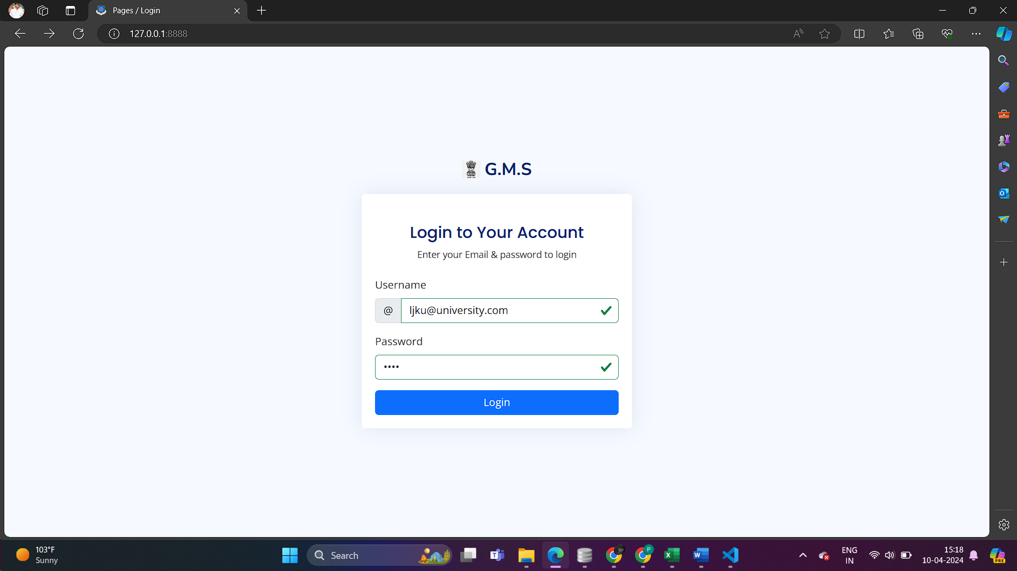

***->Dashboard Of University***

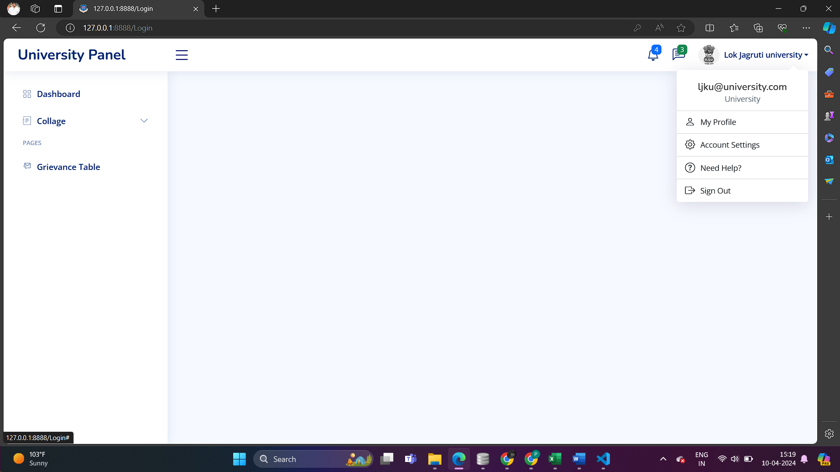

***-> Add Collage Form***

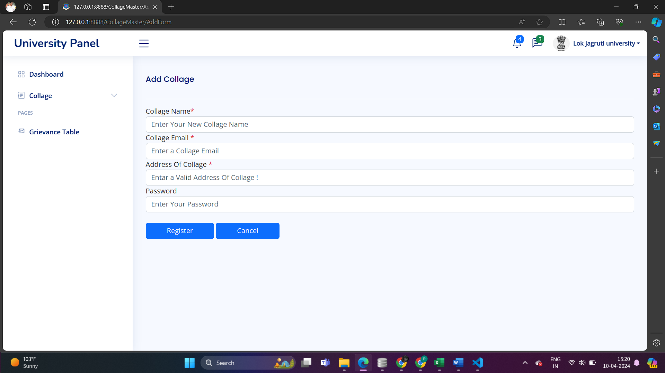

***-> Show Collage Table***

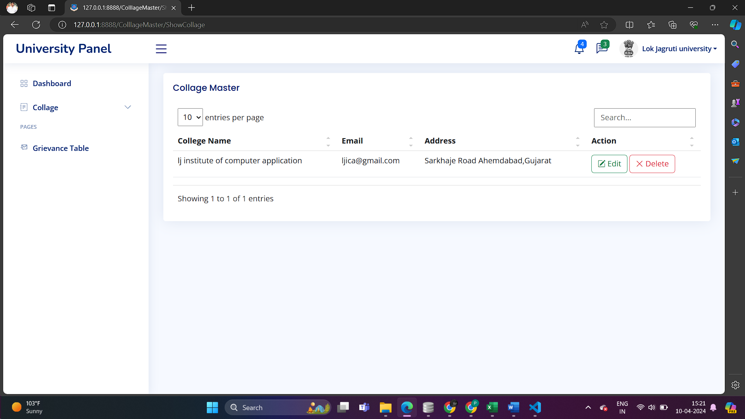

***->Edit Collage From***

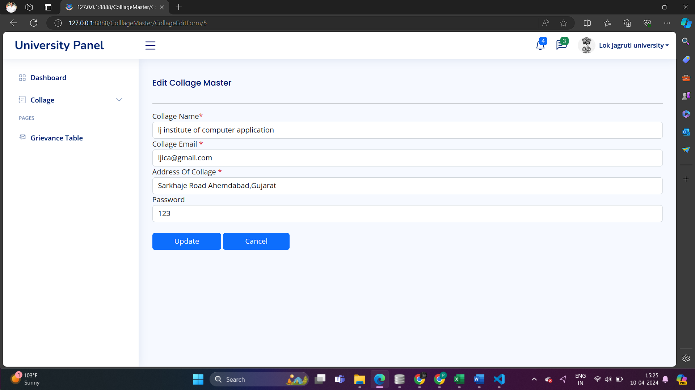

* ***Department***

***->Login from Of Department***

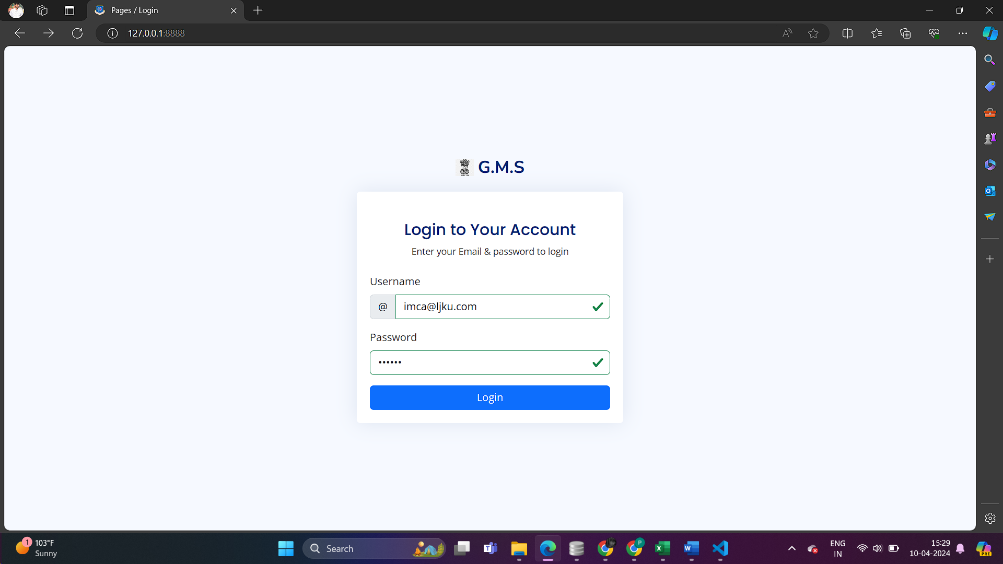

***-> Dashboard Of Department***

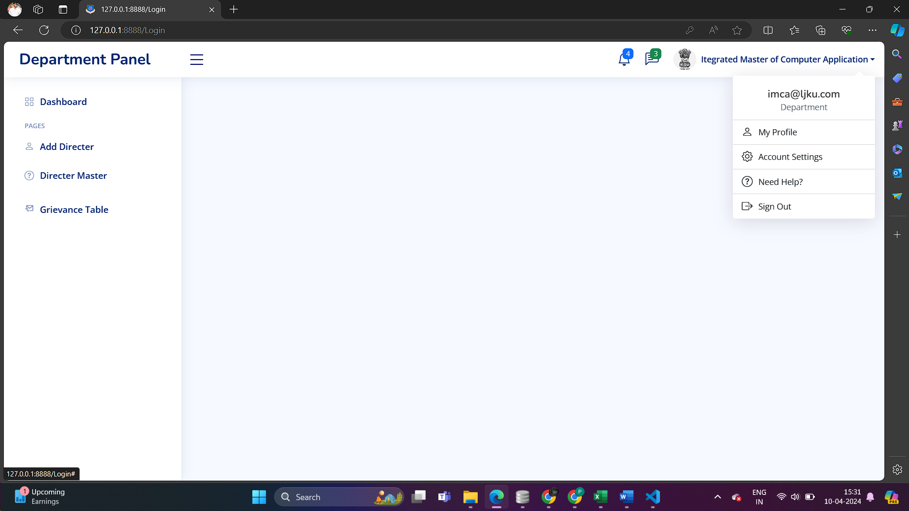

***-> Add Directer From***

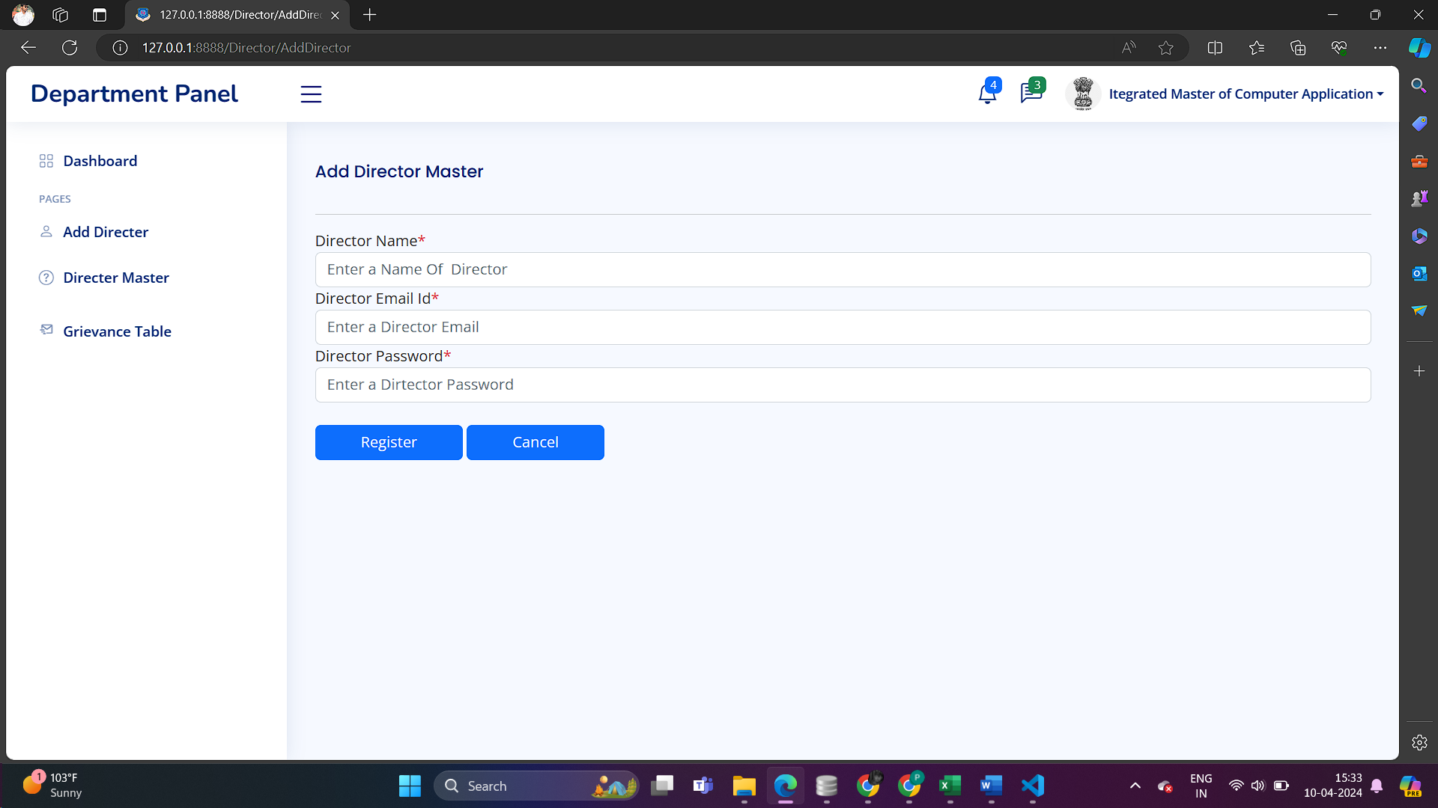

***-> List Of Hod Table***

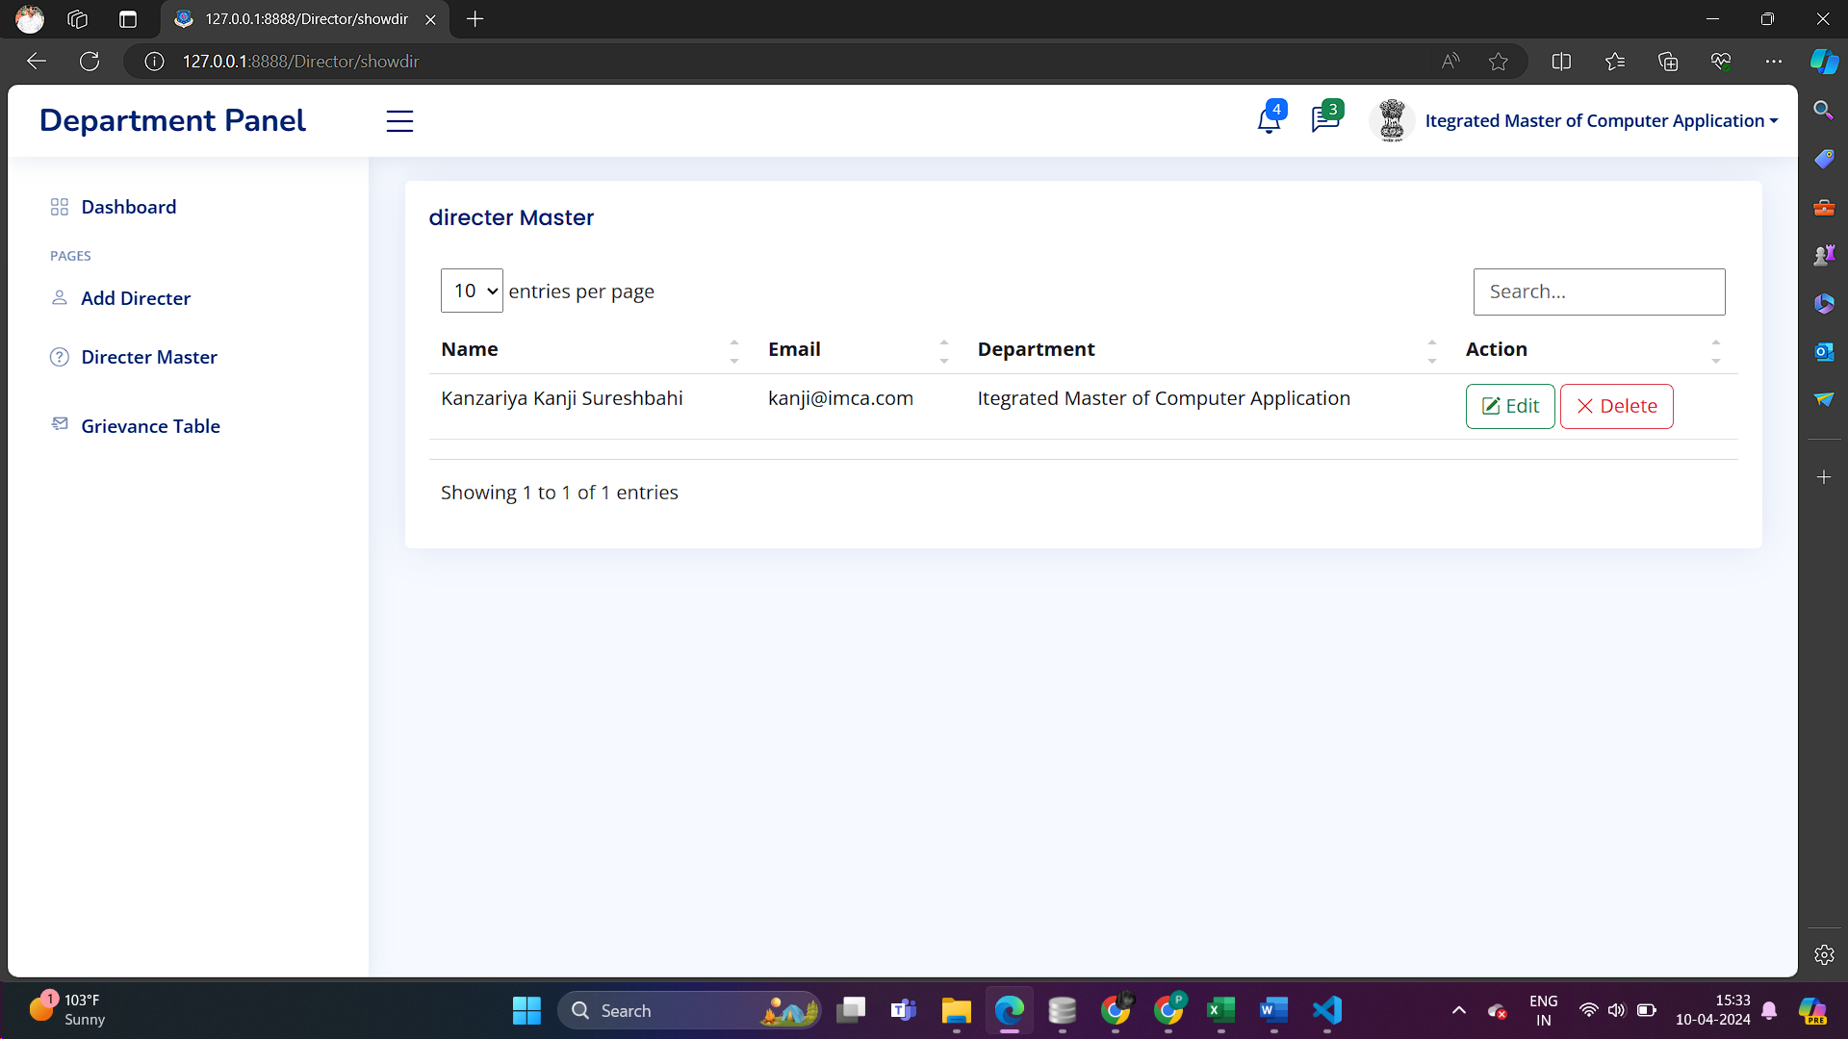

***-> Edit Form of Directer***

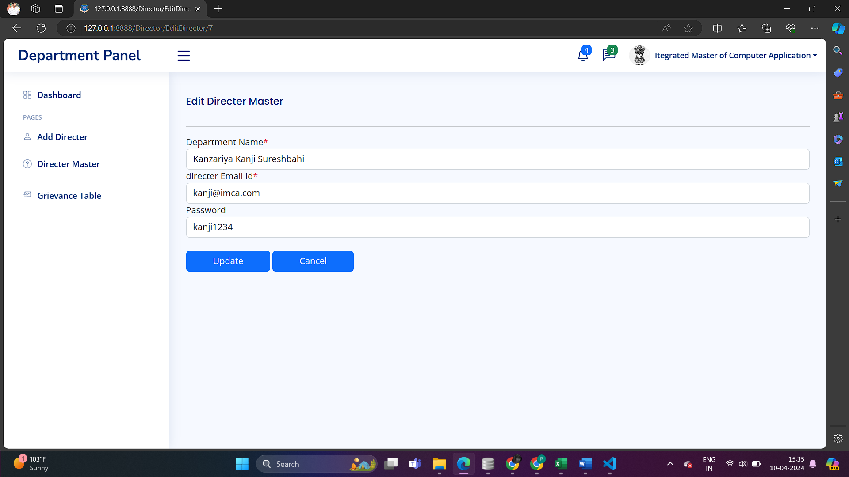

* ***Director***

***-> Login From As a Directer***

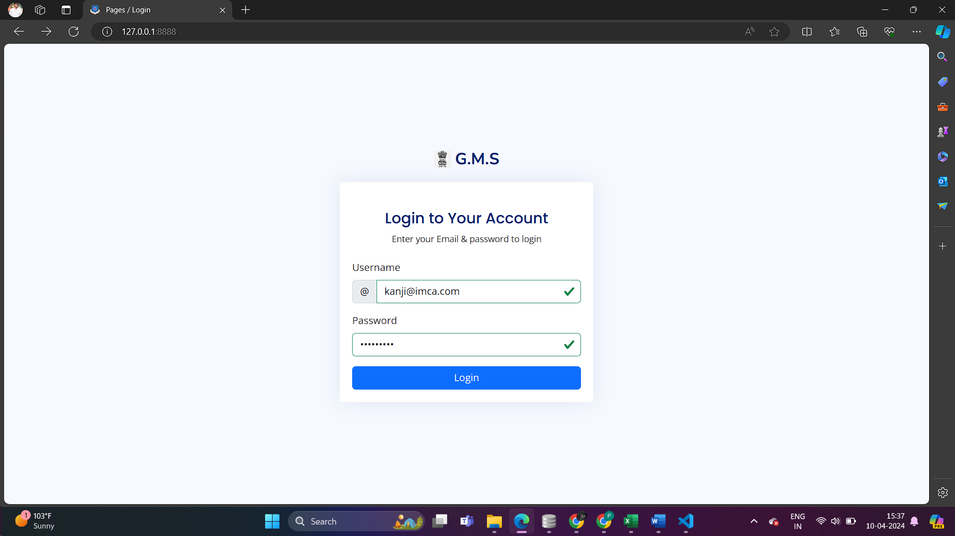

***-> Dashboard Of Directer***

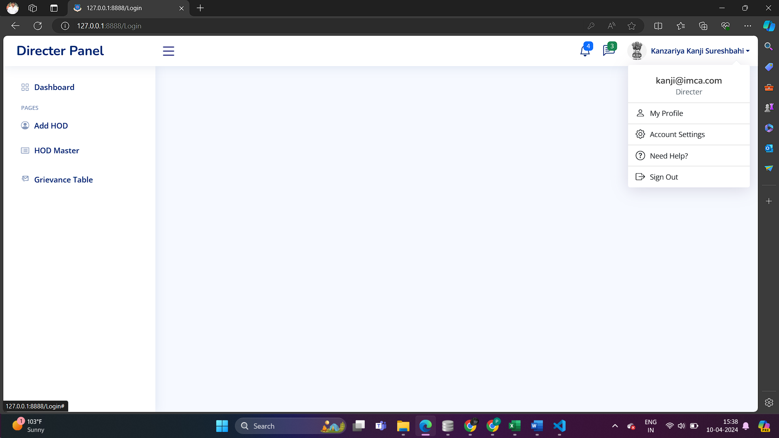

***-> Add Hod From***

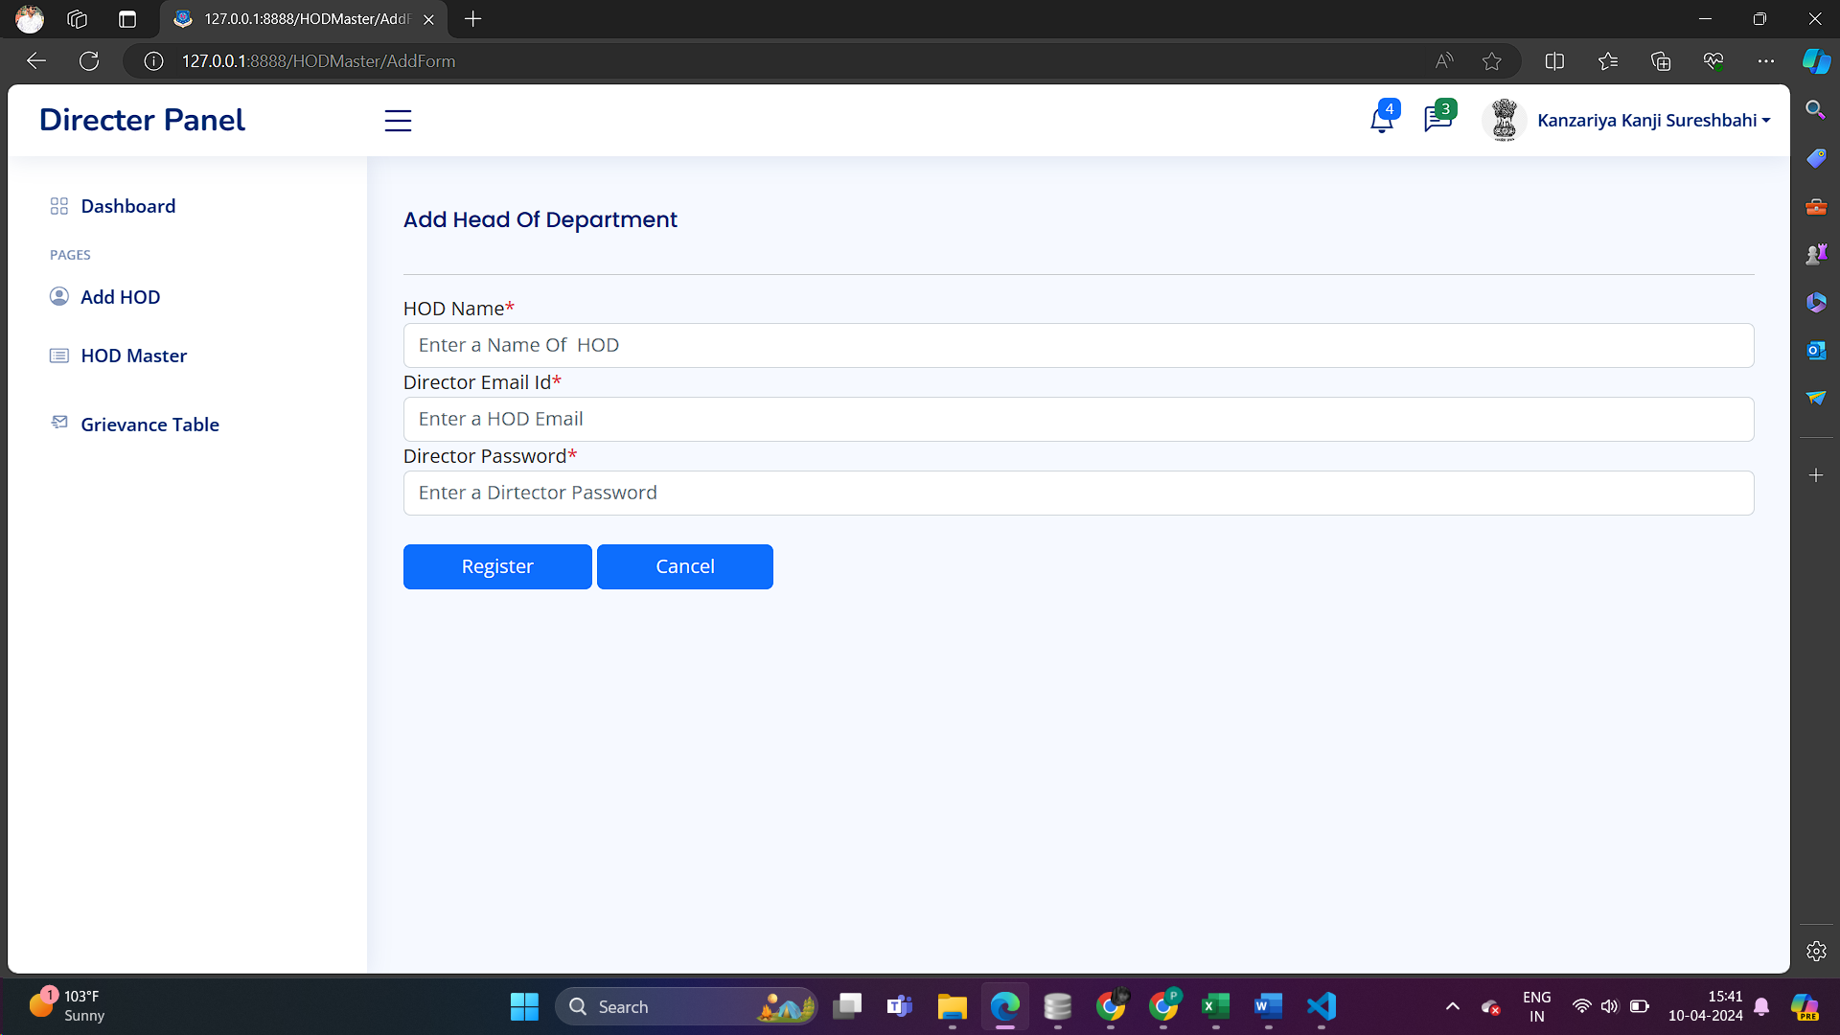

***-> List Of HOD Table***

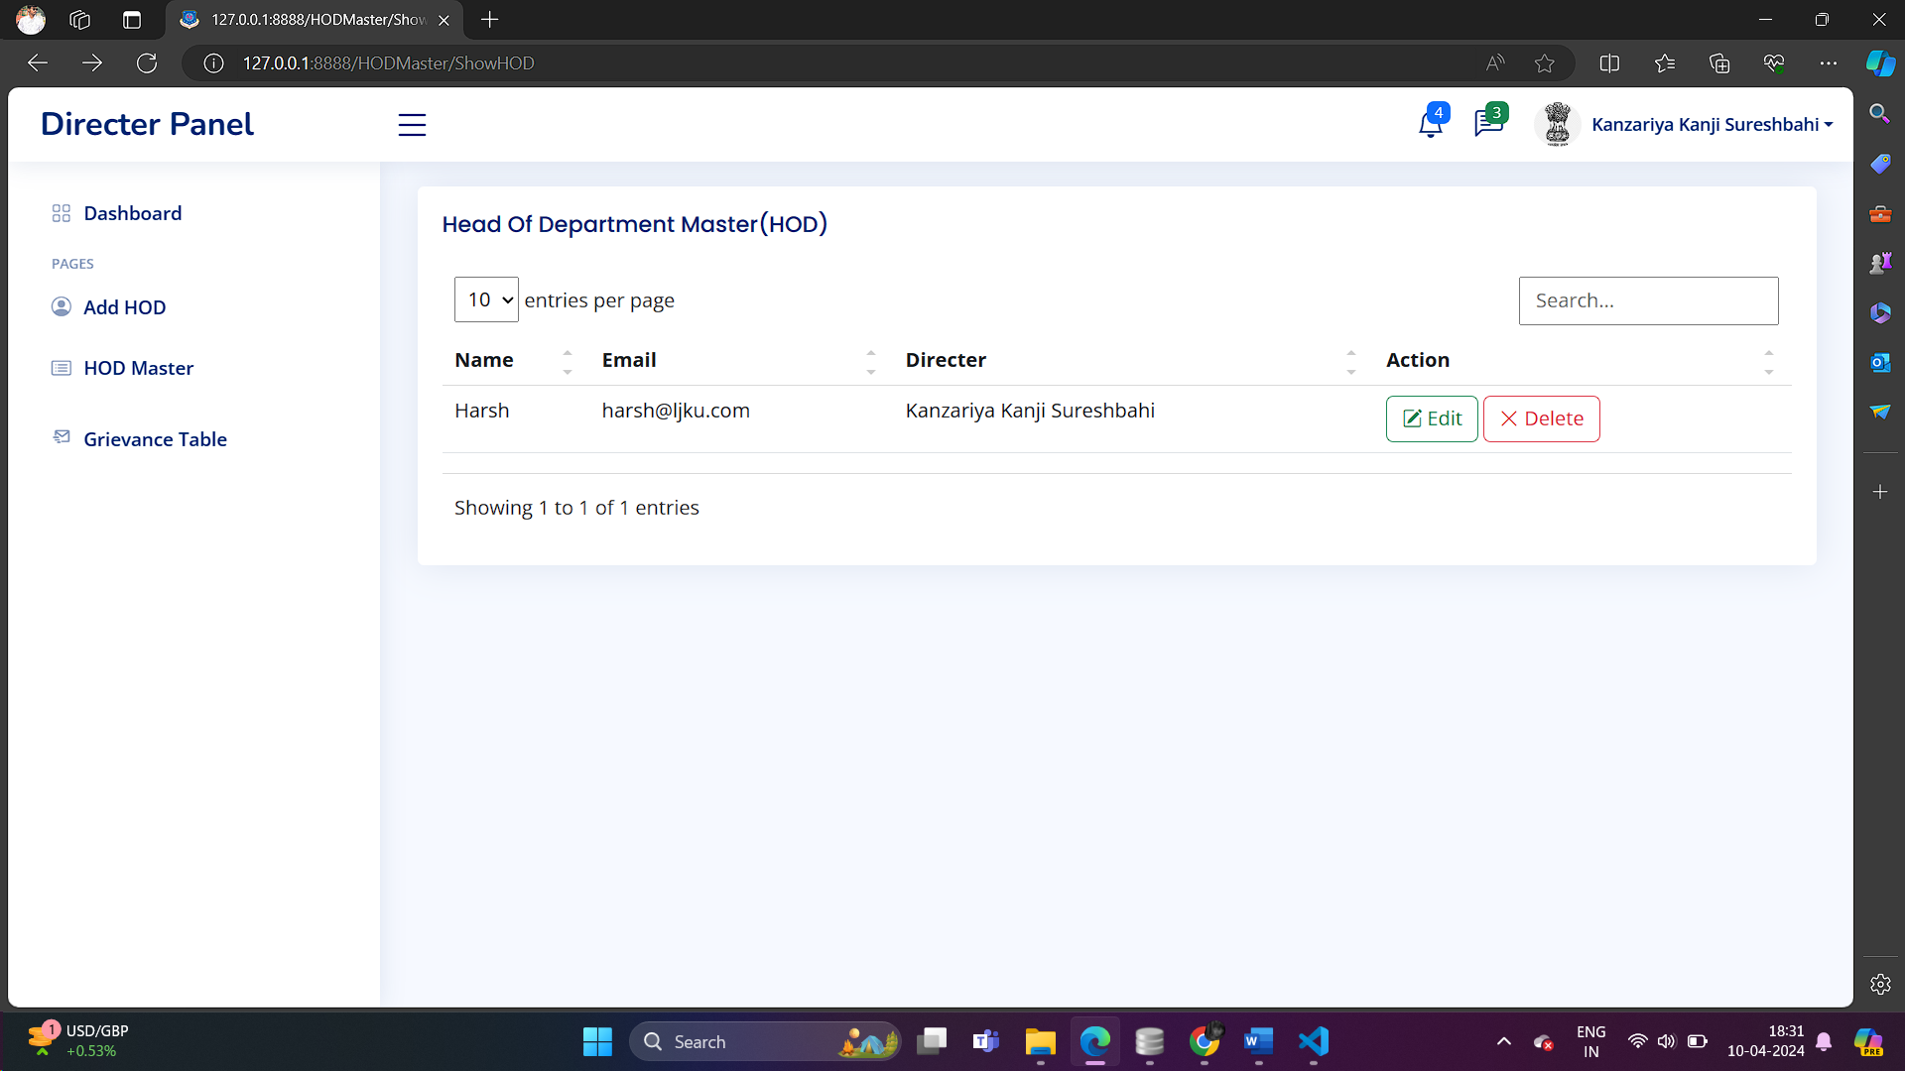

***-> Edit From of HOD***

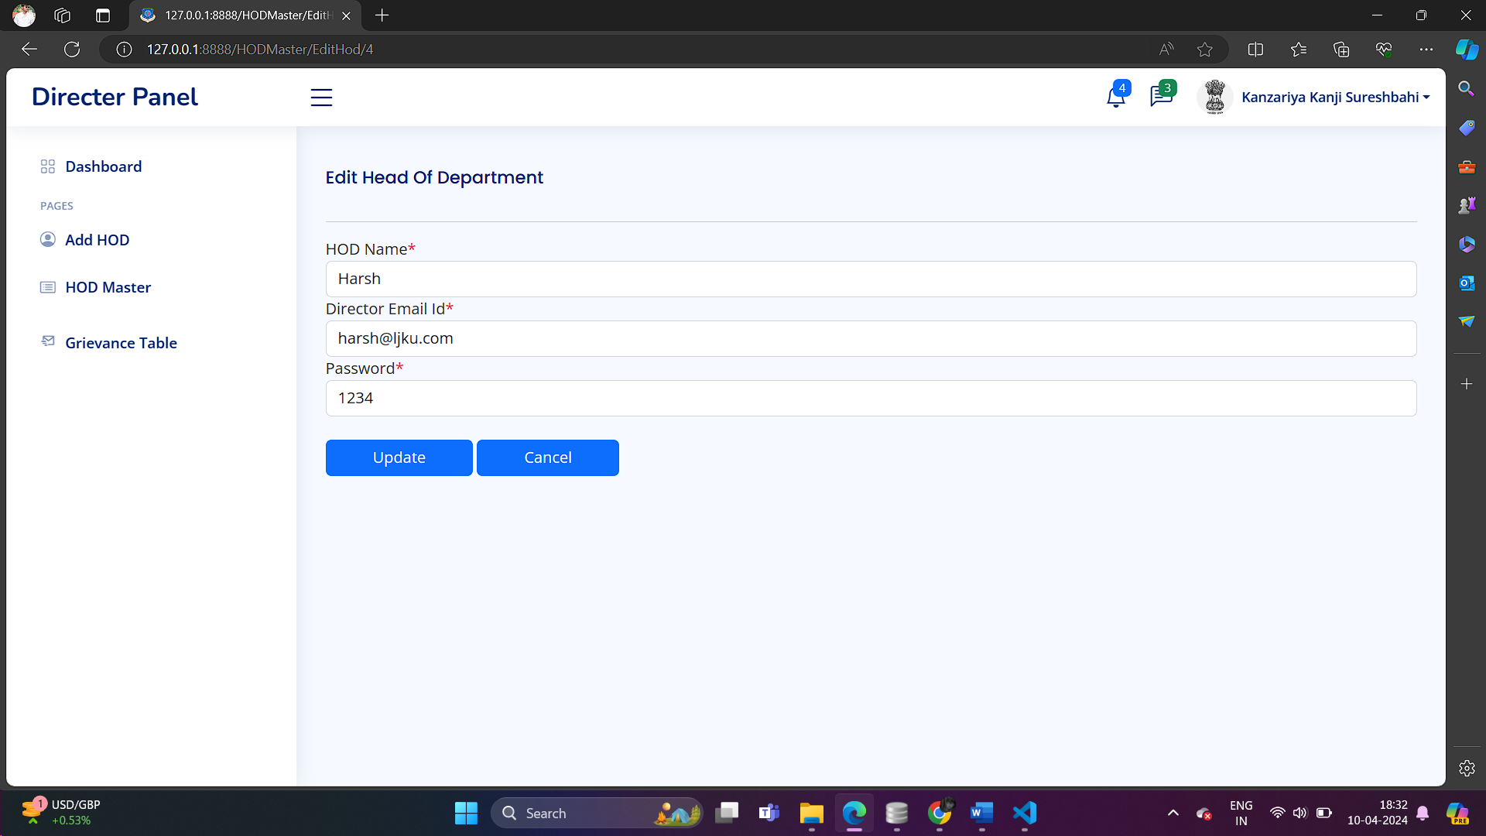

* ***Hod***

***-> Login Of HOD***

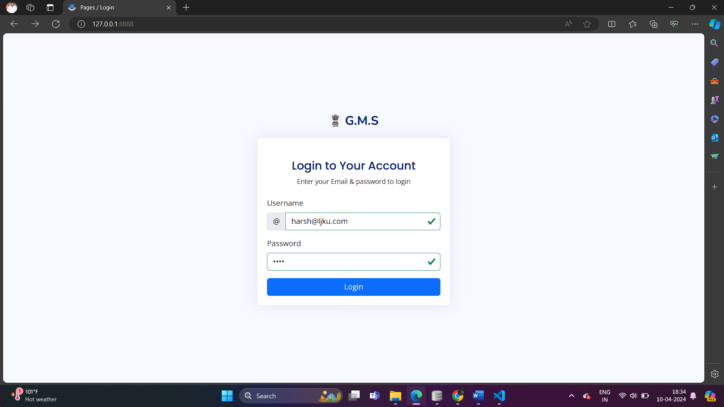

***-> Dashboard Of HOD***

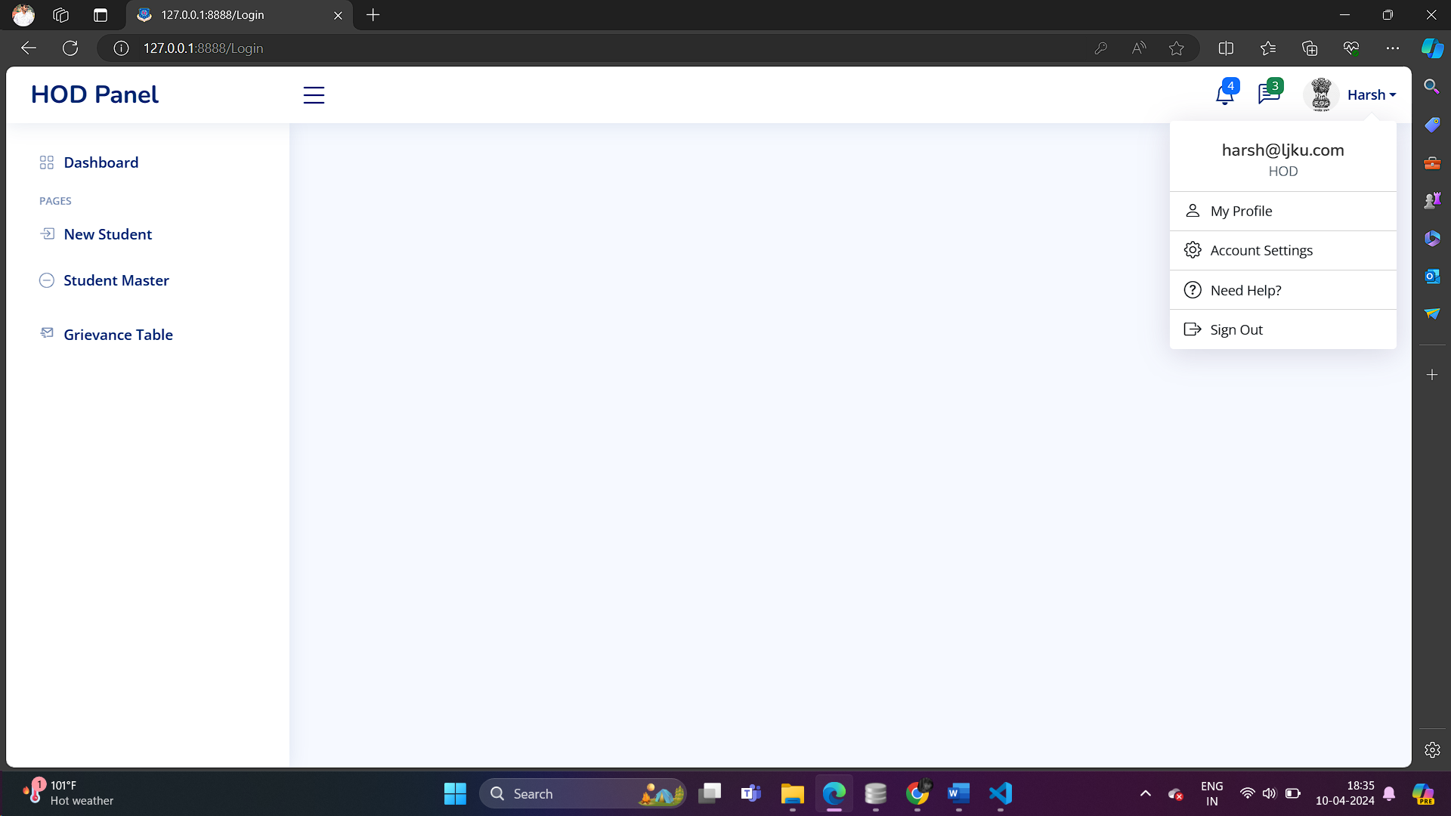

***-> Add Student From***

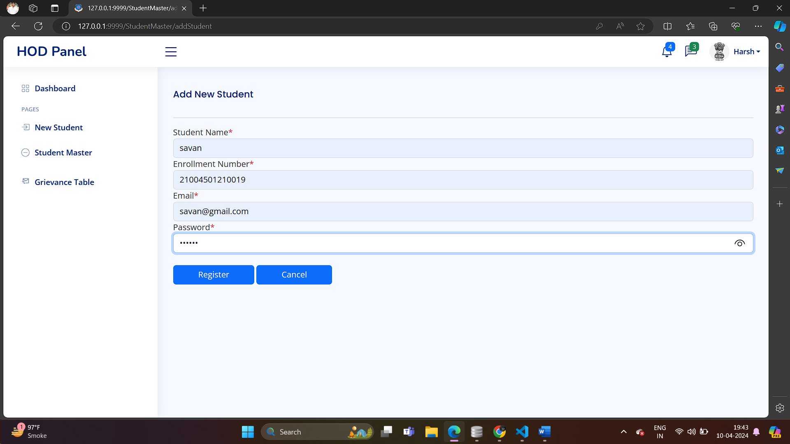

***->List Of Student Table***

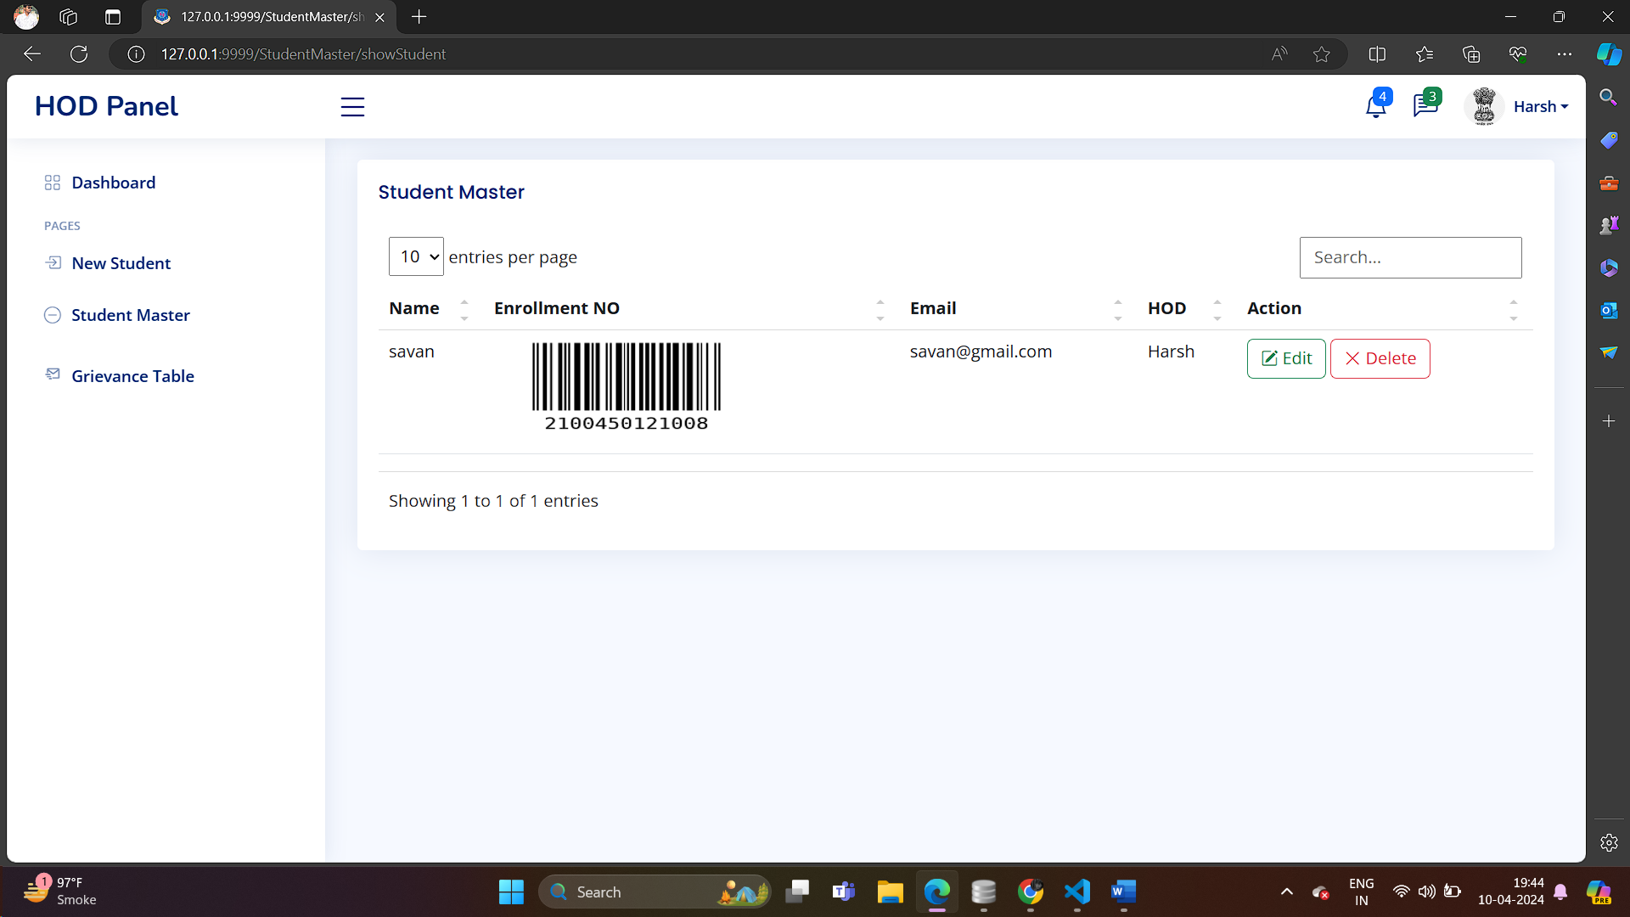

***-> Edit From Of Student***

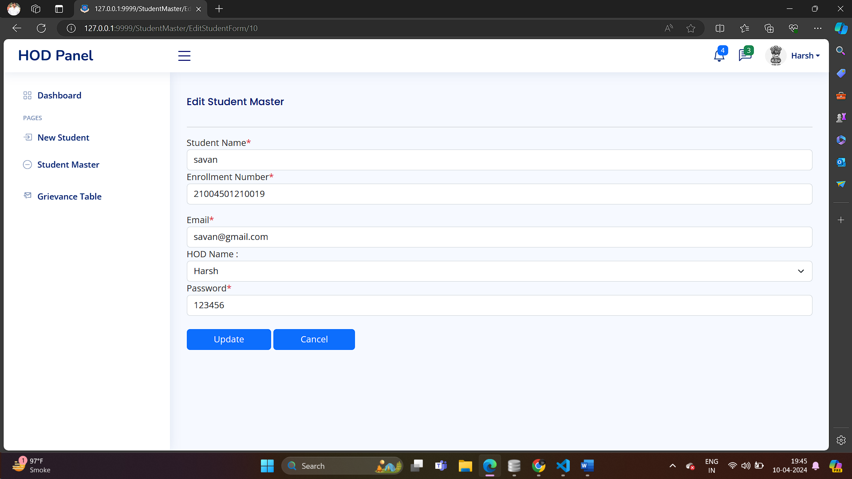

* ***Student***

***-> Login from of Student***

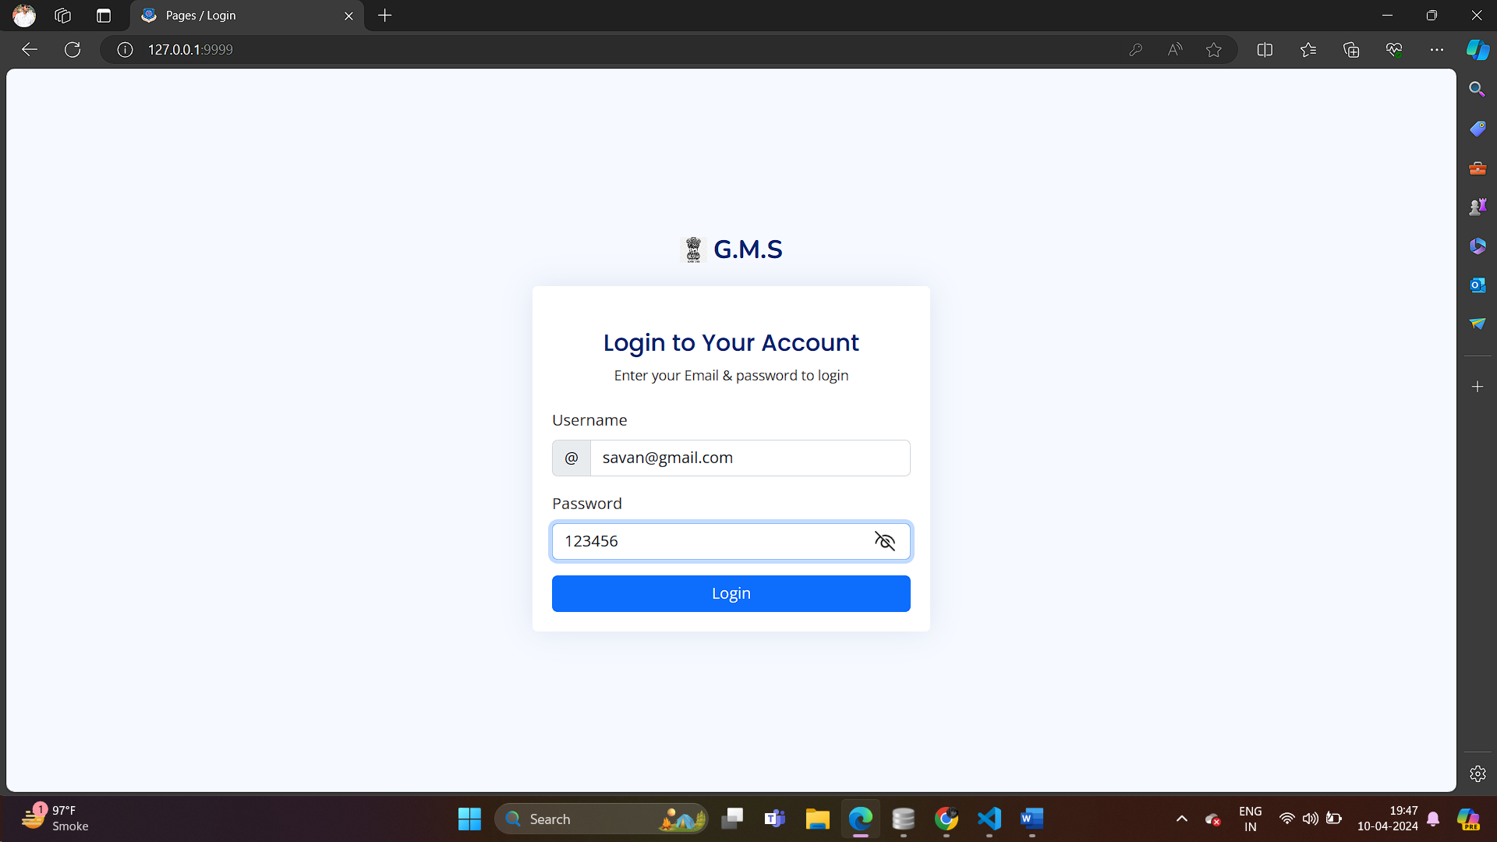

***-> Dashboard Of Student***

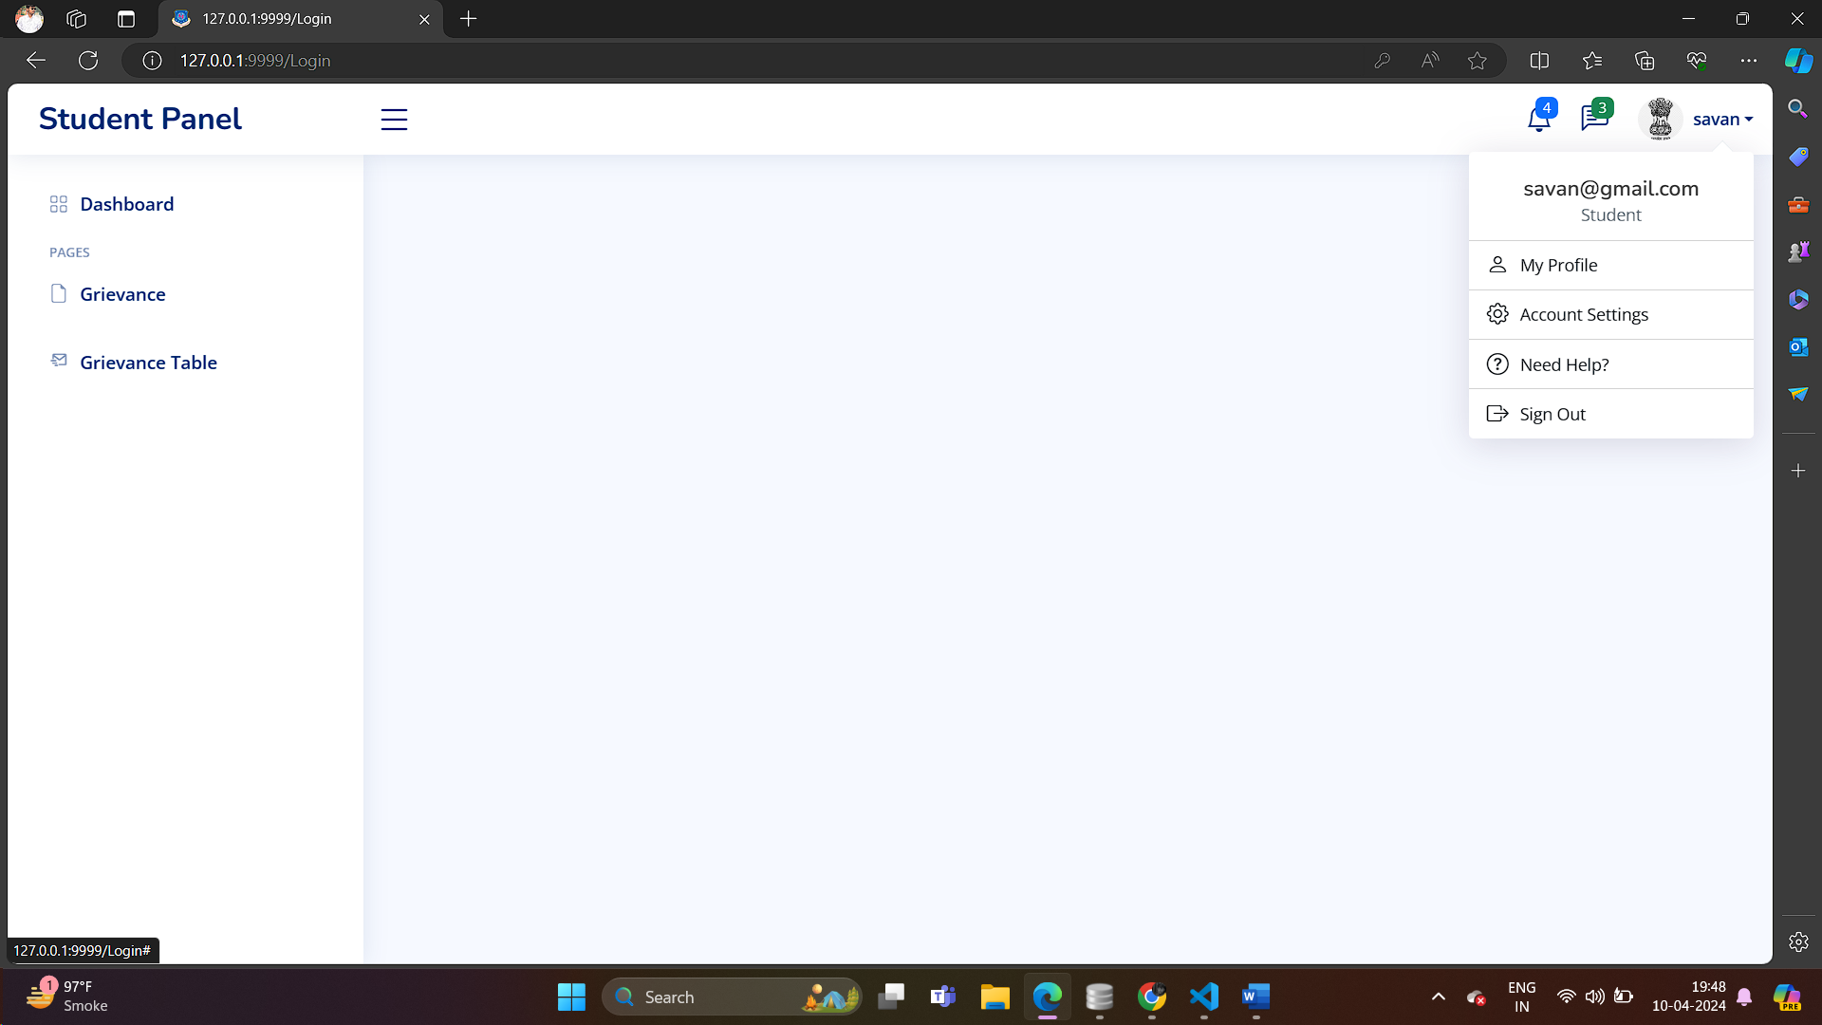

***-> Add Grievance***

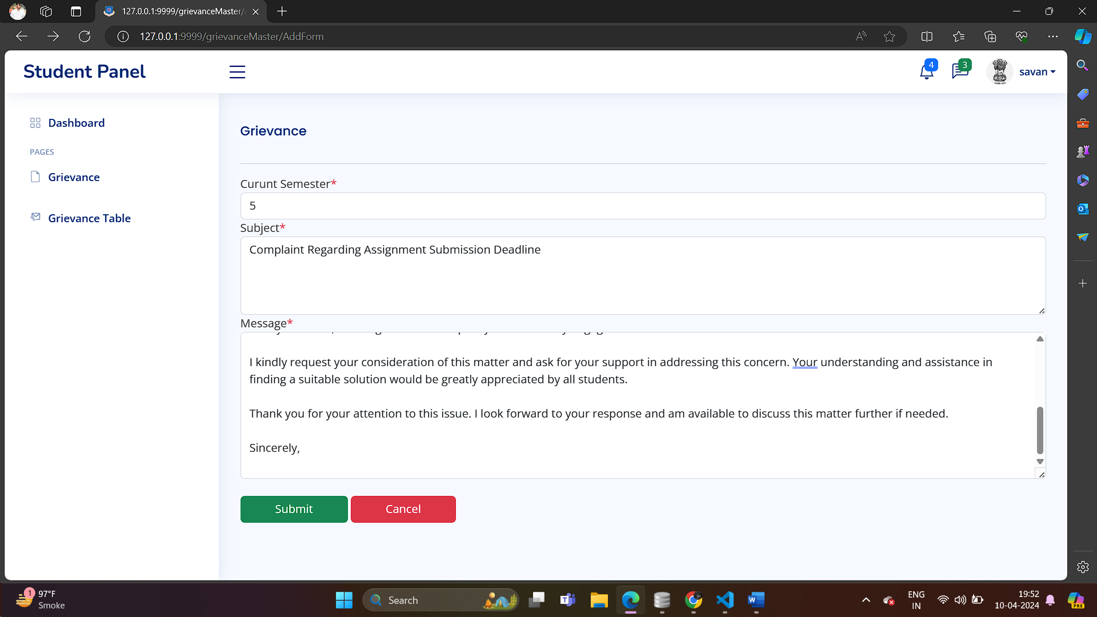

***-> Show Grievance Table***

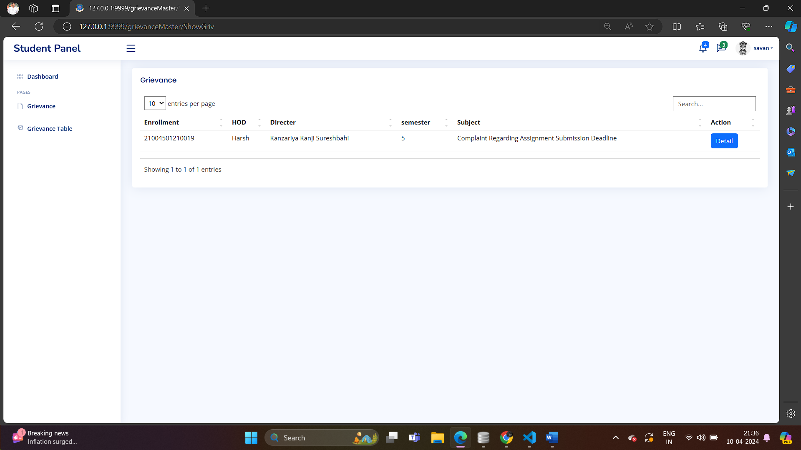

***-> Detail Of Grievance***

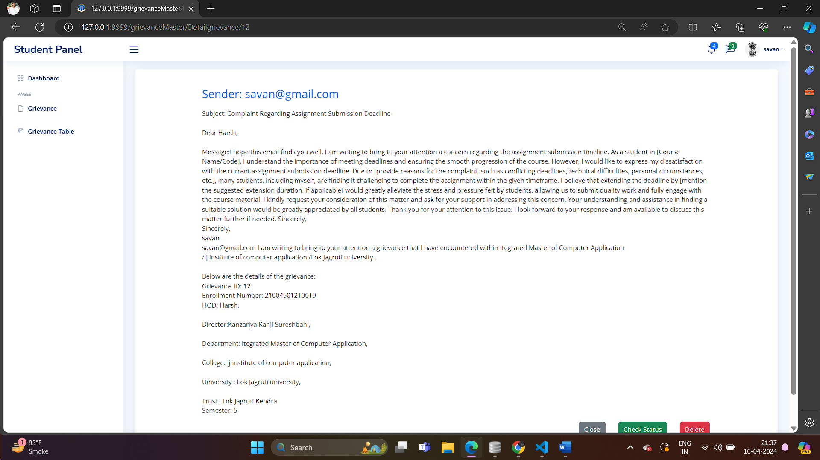

***-> Detail Grievance From HOD Side***

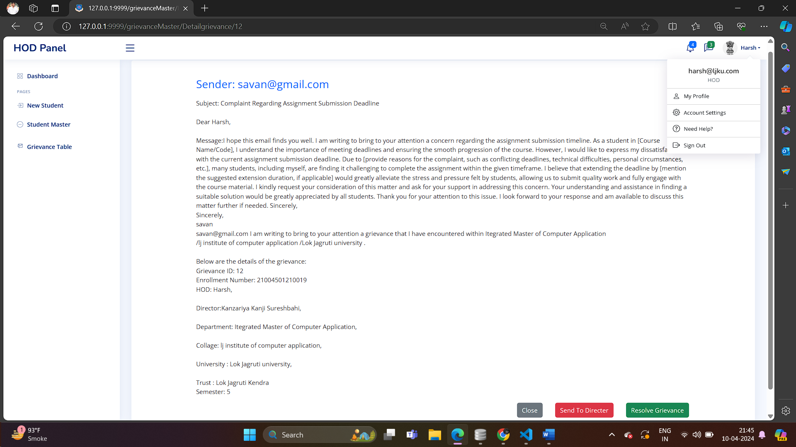

***-> Solution Of Grievance***

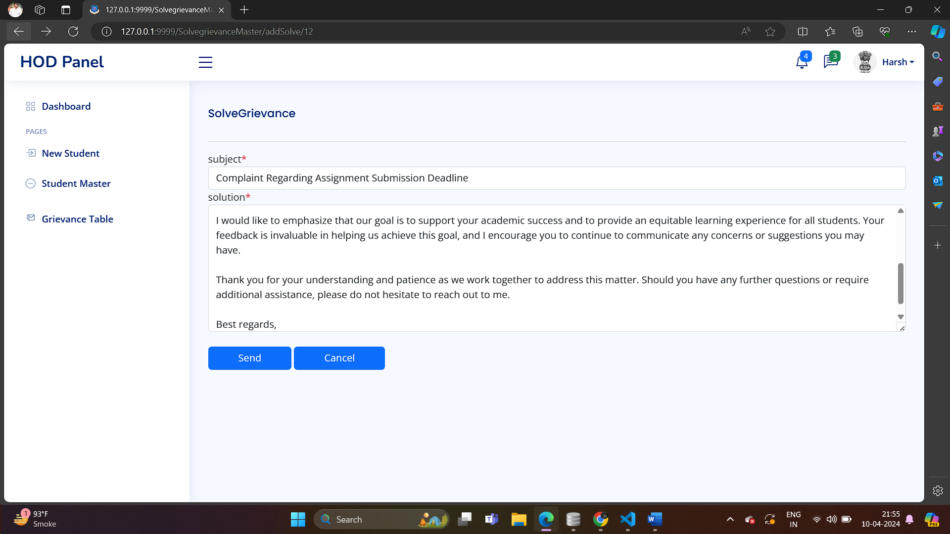

***-> Output Of As a Student***

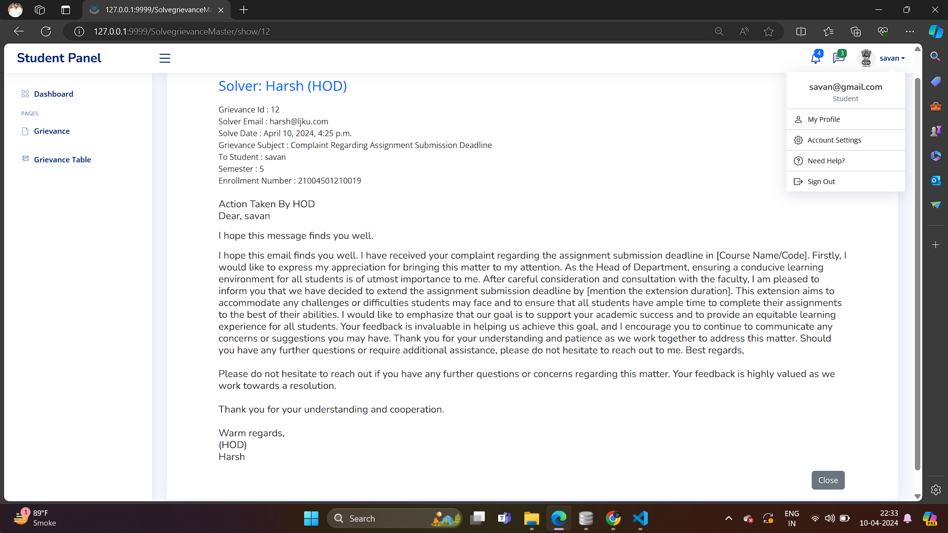

* ***Coding***

***-> Model In Project***

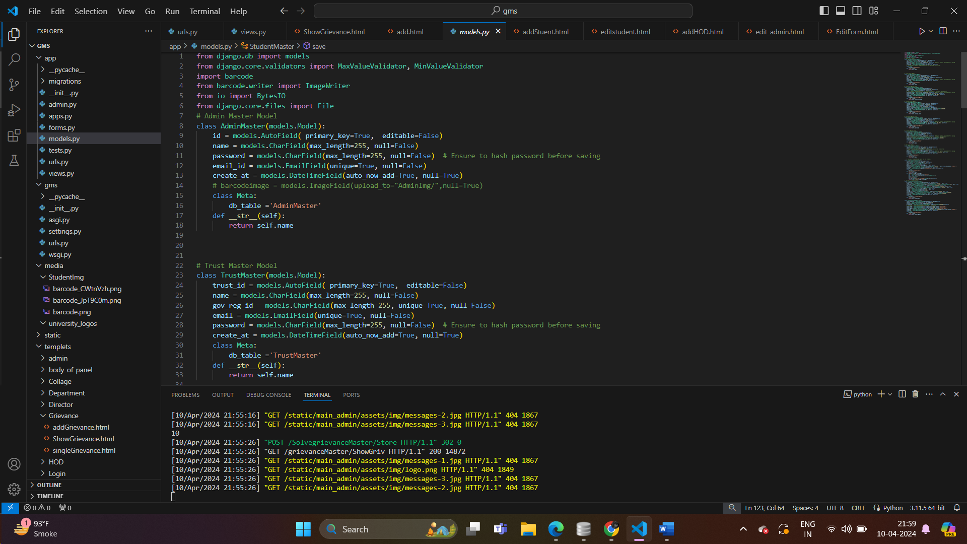

***-> Student Table Formate***

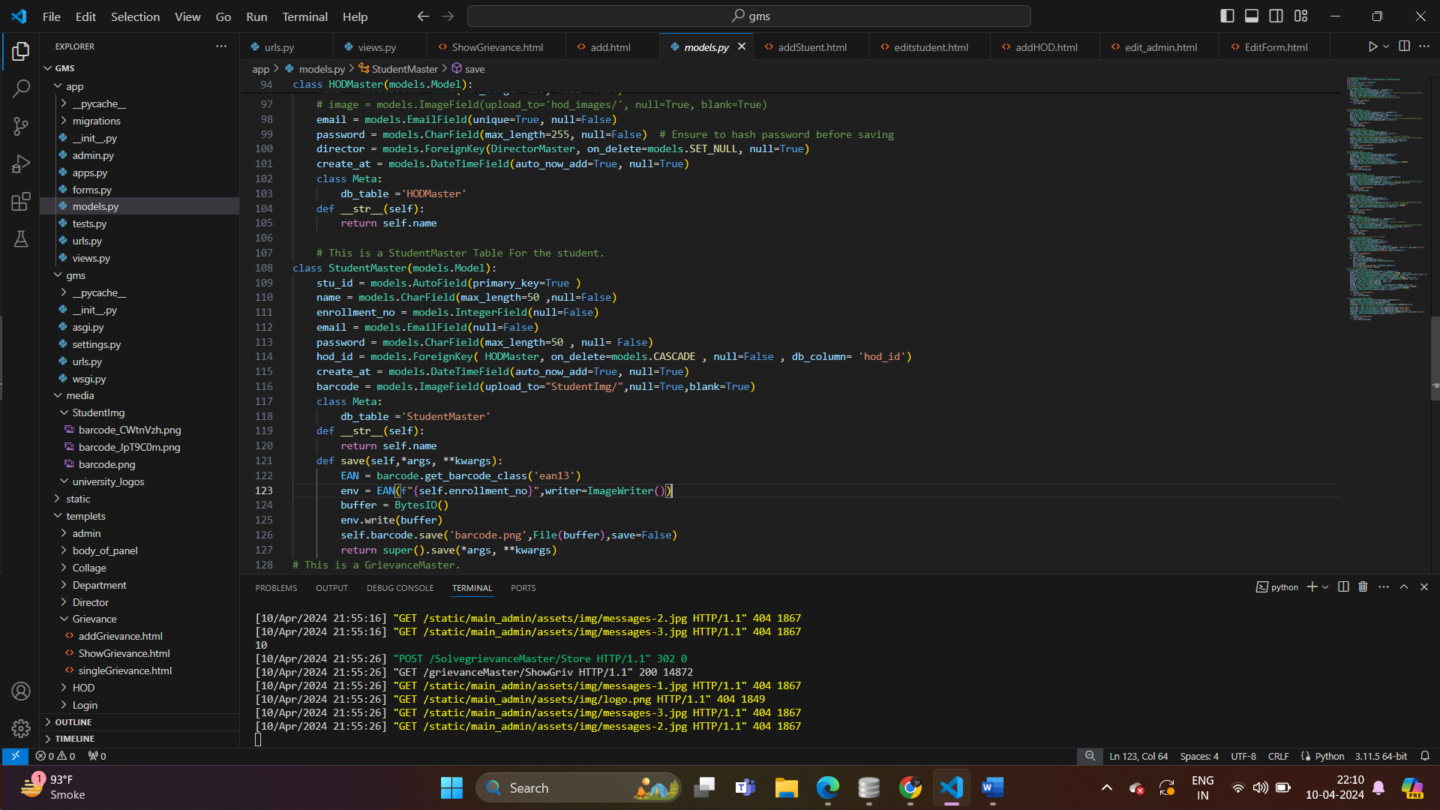

***-> Url.py In Project(Django)***

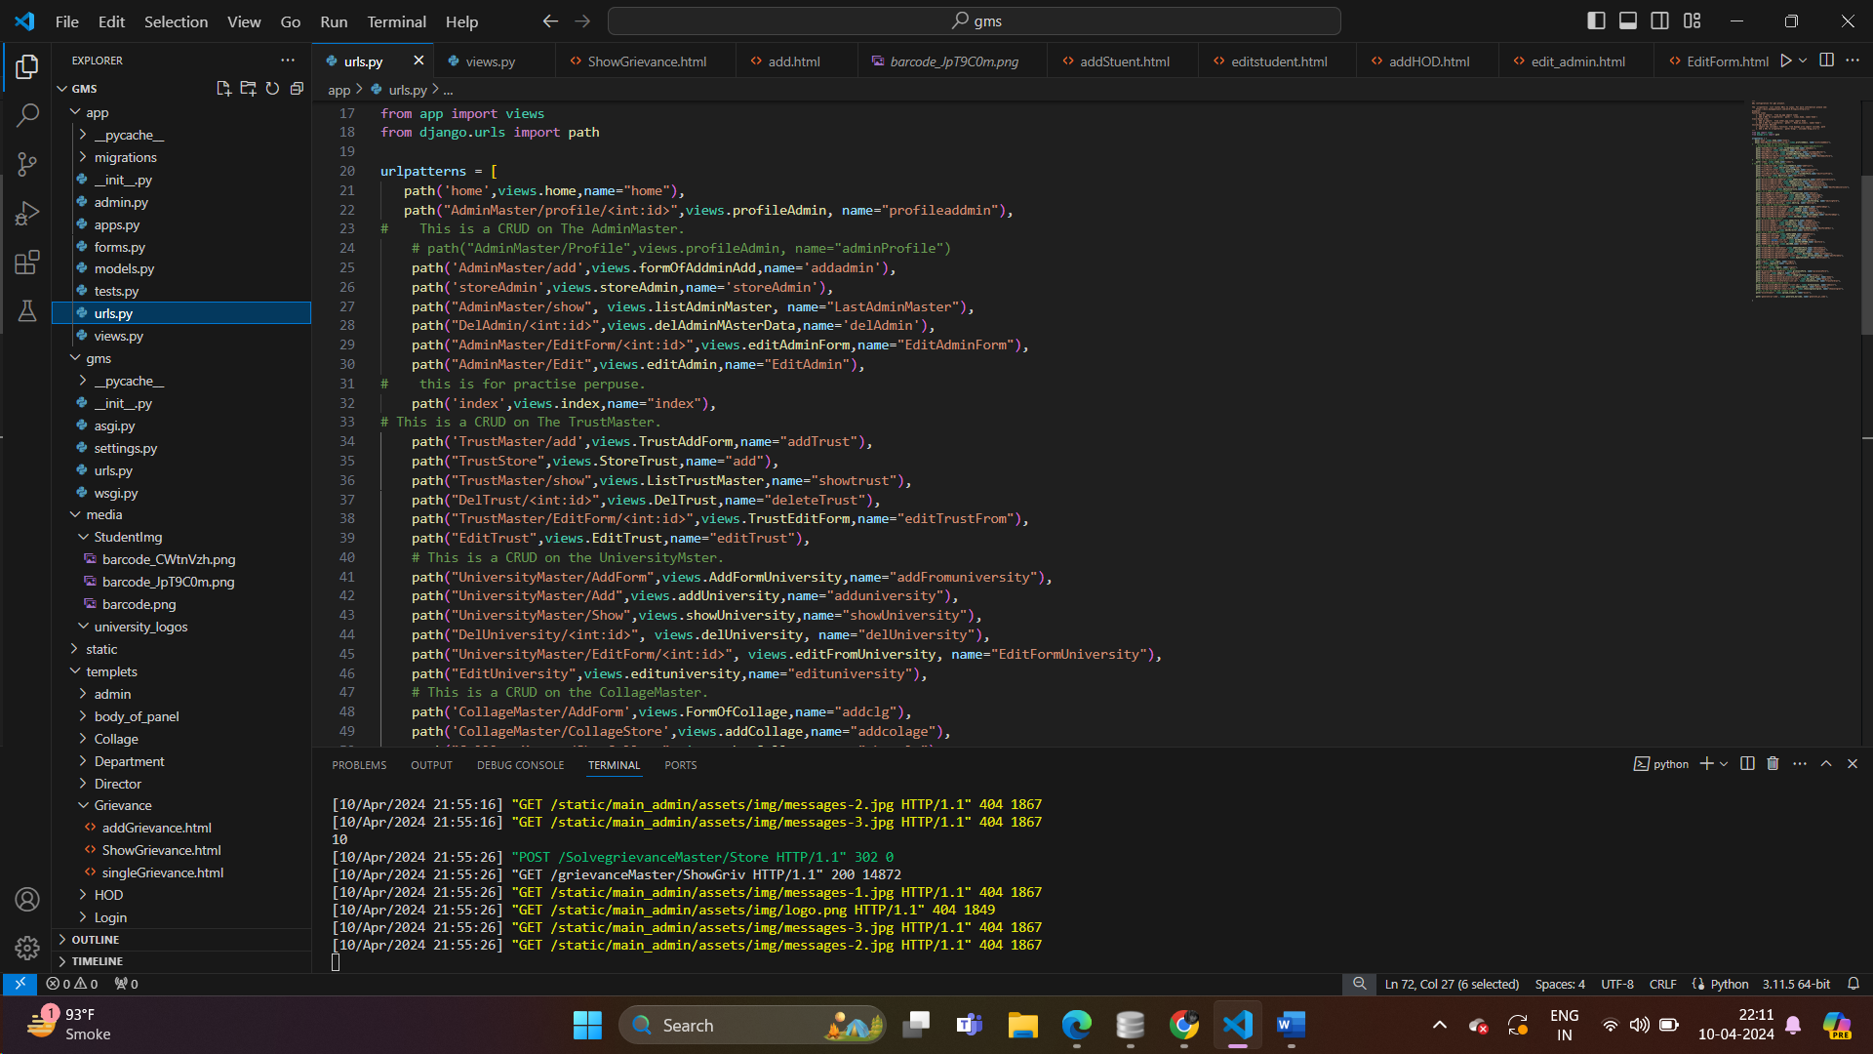

***-> Logic Of Project***

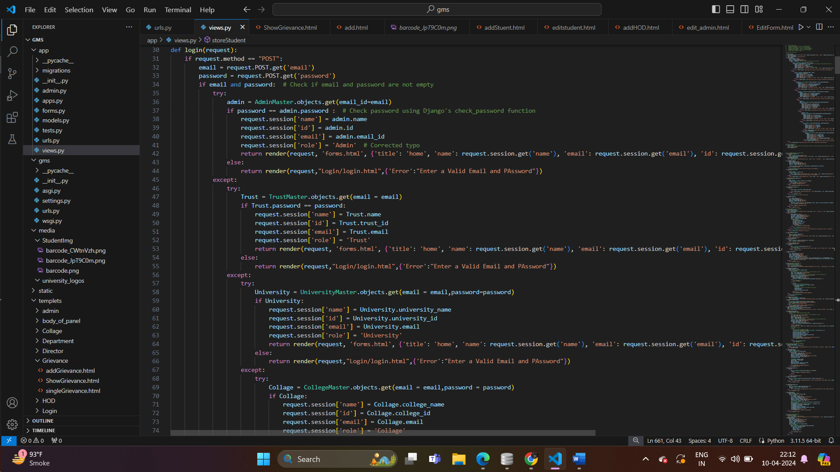

# Agile Documentation

## Agile Project Charter

| General Project Information | |
| --- | --- |
| Project Name | Student Grievance Management System |
| Project Champion | **Kanzariya Kanji,Harsh Shah,Harit Rami** |
| Project Sponsor | Company name |
| Project Manager | Monica Gahlawat |
| Stakeholders | L.J Institute Of Computer Application |
| Expected Start Date | 9-1-2024 |
| Expected Completion Date | 1-4-2024 |
| Project Details | |
| Mission | The mission of the GrievanceManagement System is to handle and control gravity-related challenges. |
| Vision | The Grievance Management System's mission is to transform the understanding, application, and navigation of gravity for the benefit of human exploration, science, and technology. |
| Scope | The scope of a Student Grievance Management System encompasses efficient complaint submission, centralized tracking, confidentiality, communication facilitation, documentation, analytics, integration, accessibility, training, compliance, and continuous improvement. |

## 

## Agile Road Map

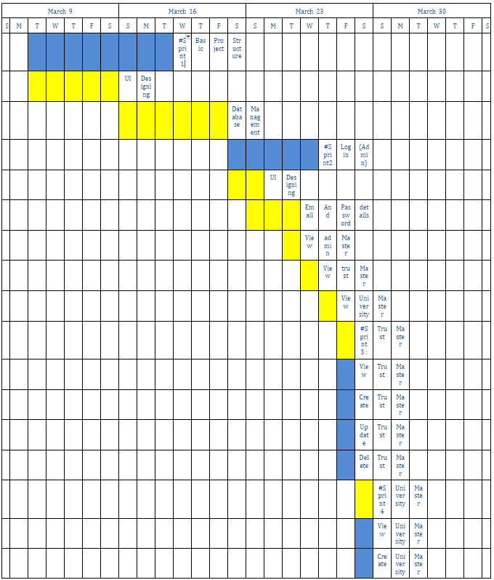

## Agile Project Plan

| Task Name | Duration | Start | Finish | Status |
| --- | --- | --- | --- | --- |
| Sprint#2:Login (Admin) | 5d | 10-1-2024 | 15-1-2024 | Complete |
| UI Designing | 2d | 10-1-2024 | 12-1--2024 | Complete |
| Email and Password | 1d | 12-1-2024 | 13-1-2024 | Complete |
| View HOD Master | 2d | 15-1-2024 | 16-1-2024 | Complete |
| View Student Master | 2d | 16-1-2024 | 17-1-2024 | Complete |
| View Admin Master | 1d | 17-1-2024 | 17-1-2024 | Complete |

## Agile User Story ( Minimum 3 Tasks)

| User Story ID | As s(type of user) | I want to perform | So that I can(achieve some task) |
| --- | --- | --- | --- |
| 1 | Admin | Login | Access My Account |
| 2 | Admin | Add Trust | Manage Trust |
| 3 | Trust | Add University | Manage University |
| 4 | University | Add College | Manage College |
| 5 | College | Add Department | Manage Department |
| 6 | Department | Add Director | Manage Director |
| 7 | Director | Add HOD | Manage HOD |
| 8 | HOD | Add Student | Manage Student |
| 9 | Student | Login | Add Grievance |

## Agile Release Plan

| Task Name | Duration | Start | Finish | Status | Release Date |
| --- | --- | --- | --- | --- | --- |
| Sprint#2:Login (Admin) | 5d | 10-1-2024 | 15-1-2024 | Complete | 15-1-2024 |
| UI Designing | 2d | 10-1-2024 | 12-1-2024 | Complete | 12-1-2024 |
| Email and Password verification | 1d | 12-1-2024 | 13-1-2024 | Complete | 13-1-2024 |
| View HOD Master | 2d | 15-1-2024 | 16-1-2024 | Complete | 16-1-2024 |
| View Student Master | 2d | 16--1-2024 | 17-1-2024 | Complete | 17-1-2024 |
| View Admin Master | 1d | 17--1-2024 | 17-1-2024 | Complete | 17-1-2024 |

## Agile Sprint Backlog

| Task Name | Story | Sprint Ready | Priority | Status | Story Point |
| --- | --- | --- | --- | --- | --- |
| Sprint#1:Login (Admin) | Yes | Yes | High | Complete | 10 |
| UI Designing | Yes | Yes | High | Complete | 8 |
| Email and Password Verification | Yes | Yes | High | Complete | 8 |
| View HOD Master | Yes | Yes | High | Complete | 2 |
| View Student Master | Yes | Yes | Medium | Complete | 2 |
| View Admin Master | Yes | Yes | Medium | Complete | 2 |

## Agile Test Plan

| Project Name | | Examination System | | | Device | | HP intel core i3  7th gen | |
| --- | --- | --- | --- | --- | --- | --- | --- | --- |
| Test Case Id | | 1 | | | Test Title | | **Add a student** | |
| Module Name | | Manage Student Master | | | Tested By | | Kanzariya Kanji | |
| Priority | | High | | | Execution Date | | 16-01-2024 | |
| Test | Test Step | | Action | Expected Result | | Actual Result | | Pass |
| 1 | Click on “add using excel sheet” | | Open excel sheet and add student data | Open excel sheet and add student | | Students are added to the database . | | Yes |
| 2 | student email-id is Invalid | | Student is not add in system | Students are not added to the system . | | show the error message | | No |
| 3 | student Password is Invalid | | Student is not add in system | Students are not added to the system . | | show the error message | | No |
| 4 | student add manually | | Student add in database | Student add in database | | Student is add in database | | Yes |

## Earned-value and burn charts

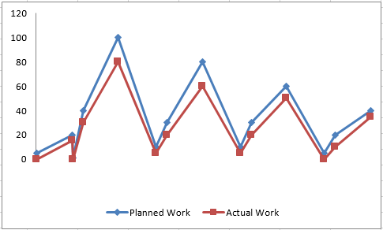

# Proposed Enhancements

* Anonymous Reporting Option: Implement an option for students to submit grievances anonymously. This can encourage more students to come forward with their concerns without fear of retaliation.
* Automated Tracking System: Develop a system to automatically track the progress of grievances from submission to resolution. This can include notifications to both students and administrators at key stages of the process, ensuring transparency and accountability.
* User-Friendly Interface: Improve the user interface to make it more intuitive and user-friendly for both students and administrators. This can include clear navigation, easy-to-use forms for submitting grievances, and a responsive design accessible across devices.

# Conclusion

In conclusion, enhancing a student grievance management system with features such as anonymous reporting, automated tracking, and a user-friendly interface can significantly improve its effectiveness in addressing student concerns. By implementing these enhancements, educational institutions can foster a supportive academic environment, promote transparency and accountability, and better serve the needs of their student community. It's imperative for institutions to continually review and update their grievance management systems to ensure they remain responsive to the evolving needs of students and maintain trust and confidence in the academic community.

# Bibliography

<https://pypi.org/project/django-barcode/>

https://pypi.org/project/pillow/

<https://www.academiaerp.com/blog/student-grievance-management-using-technology/>

https://indusedu.org/pdfs/IJREISS/IJREISS_3046_52283.pdf